Apache JMeter v5 .5

It is a good practice to define most of the things @Test-plan level so that they can be scoped n accessed throughout the test-plan.

It is recommended that you can Create n Debug/test the tests from Jmeter GUI but if you want to run the test once it is created and working fine then to run the test you can use JMeter CLI this is becoz GUI takes more computer resources as compared to JMeter CLI so once we are confirm that test plan is working fine then we can use CLI to run the test.

To Run the jmeter on CLI open cmd.exe go to jmeter installed path/bin then type jmeter.bat -n -t “complete-path-of-jmxfile -tobeRun” -l “complete-path-of-outputfile -tobecreated with extension” -e -o “complete-path-of-emptyfolder-where-Reports(index.html)-tobecreated”

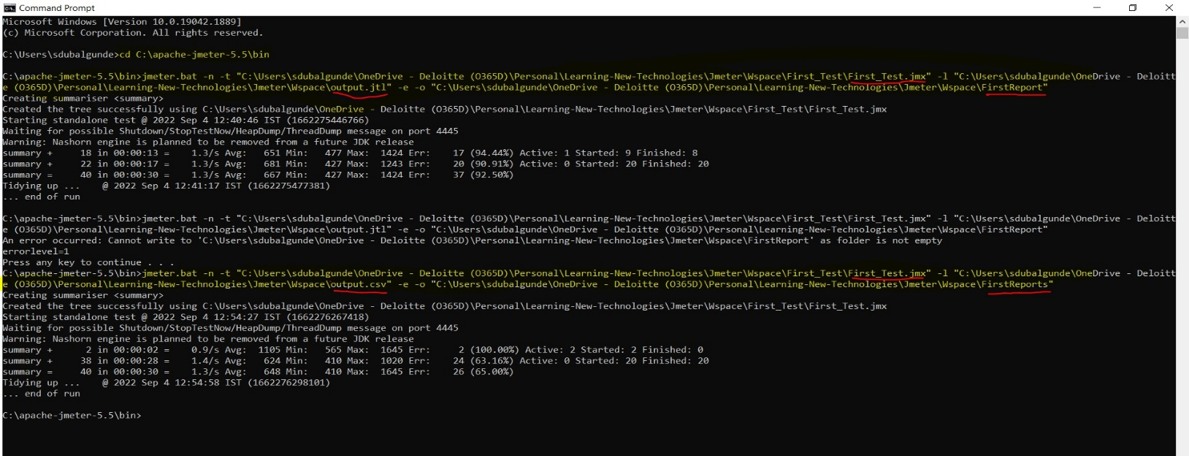

Commands used in above screenshots are:

1. Cd C:\apache-jmeter-5.5\bin
2. jmeter.bat -n -t “C:\Users\sdubalgunde\OneDrive - Deloitte (O365D)\Personal\Learning-New-Technologies\Jmeter\Wspace\First_Test\First_Test.jmx” -l “C:\Users\sdubalgunde\OneDrive - Deloitte (O365D)\Personal\Learning-New-Technologies\Jmeter\Wspace\output.jtl” -e -o “C:\Users\sdubalgunde\OneDrive - Deloitte (O365D)\Personal\Learning-New-Technologies\Jmeter\Wspace\FirstReport"
3. jmeter.bat -n -t “C:\Users\sdubalgunde\OneDrive - Deloitte (O365D)\Personal\Learning-New-Technologies\Jmeter\Wspace\First_Test\First_Test.jmx” -l “C:\Users\sdubalgunde\OneDrive - Deloitte (O365D)\Personal\Learning-New-Technologies\Jmeter\Wspace\output.csv” -e -o “C:\Users\sdubalgunde\OneDrive - Deloitte (O365D)\Personal\Learning-New-Technologies\Jmeter\Wspace\FirstReports"

OUTPUT OF THE BELOW COMMANDS WILL BE

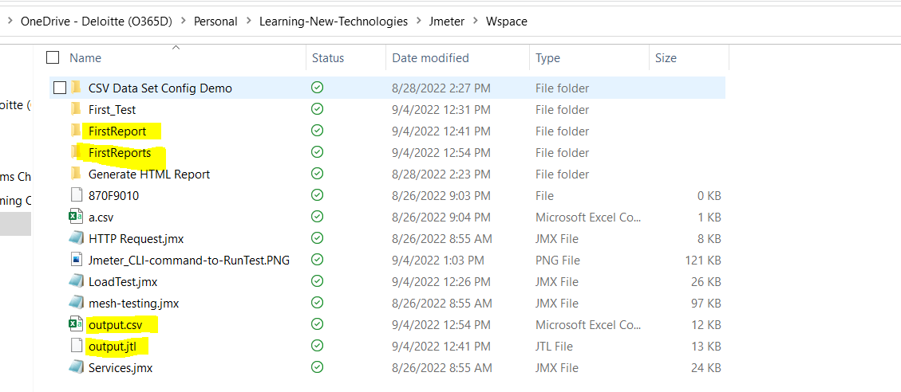

Oncecommand run successfully n generates the expected output file with reports in specified folder then if we run the same command again it will throw the error like below

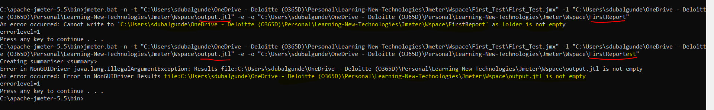

Switches used in above jmeter commands

-n = Tells Jmeter to start the jmeter.bat to start in non GUI mode(CLI mode)

-t = tells jmeter to use specified jmx file to run the test. here complete-path-of-jmxfile -tobeRun should be a value in “value” “complete-path-of-jmxfile -tobeRun” for eg: “C:\Users\sdubalgunde\OneDrive - Deloitte (O365D)\Personal\Learning-New-Technologies\Jmeter\Wspace\First_Test\First_Test.jmx”

-l = tells the jmeter to generate the output file in mentioned path with extension given. complete-path-of-outputfile -tobecreated with extension for eg: “C:\Users\sdubalgunde\OneDrive - Deloitte (O365D)\Personal\Learning-New-Technologies\Jmeter\Wspace\output.csv”

-e = tells jmeter to perform actions at the end of the run

-o = tells jmeter to generate the reports inside the an empty folder mentioned in the value. complete-path-of-emptyfolder-where-Reports(index.html)-tobecreated for eg: “C:\Users\sdubalgunde\OneDrive - Deloitte (O365D)\Personal\Learning-New-Technologies\Jmeter\Wspace\FirstReports"

jmeter.bat -n -t “C:\Users\sdubalgunde\OneDrive - Deloitte (O365D)\Personal\Learning-New-Technologies\Jmeter\Wspace\First_Test\First_Test.jmx” -l “C:\Users\sdubalgunde\OneDrive - Deloitte (O365D)\Personal\Learning-New-Technologies\Jmeter\Wspace\output.csv” -e -o “C:\Users\sdubalgunde\OneDrive - Deloitte (O365D)\Personal\Learning-New-Technologies\Jmeter\Wspace\FirstReports"

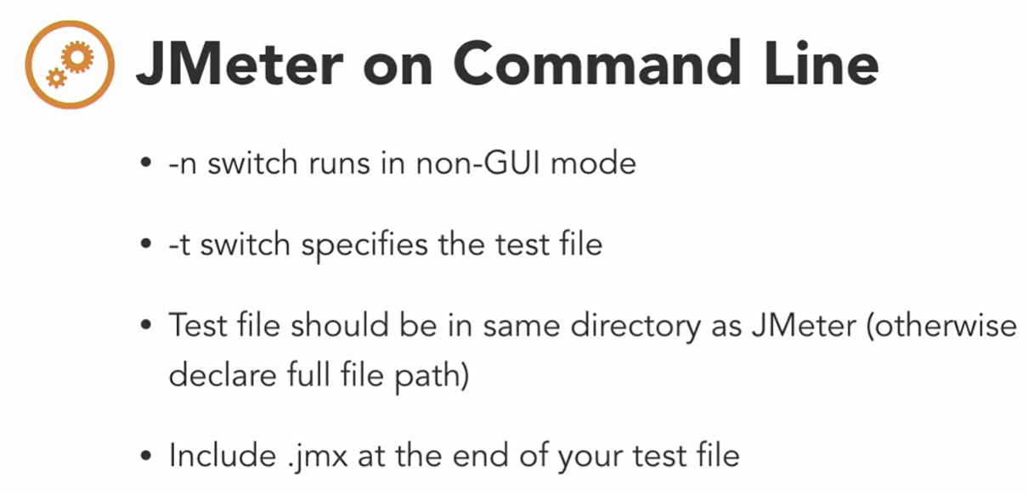

* Apache Jmeter is open-source tool,which is built on Java n used to load test the functional behavior and measure the performance.Used for load and performance test of various apps/servers,protocol type like:

Web apps

Soap App/Rest Apps

TCP

FTP

Database via JDBC

LDAP

MAIL -smtp,pop,imap etc.

It supports Recording of tests and supports CLI and also generates reports.

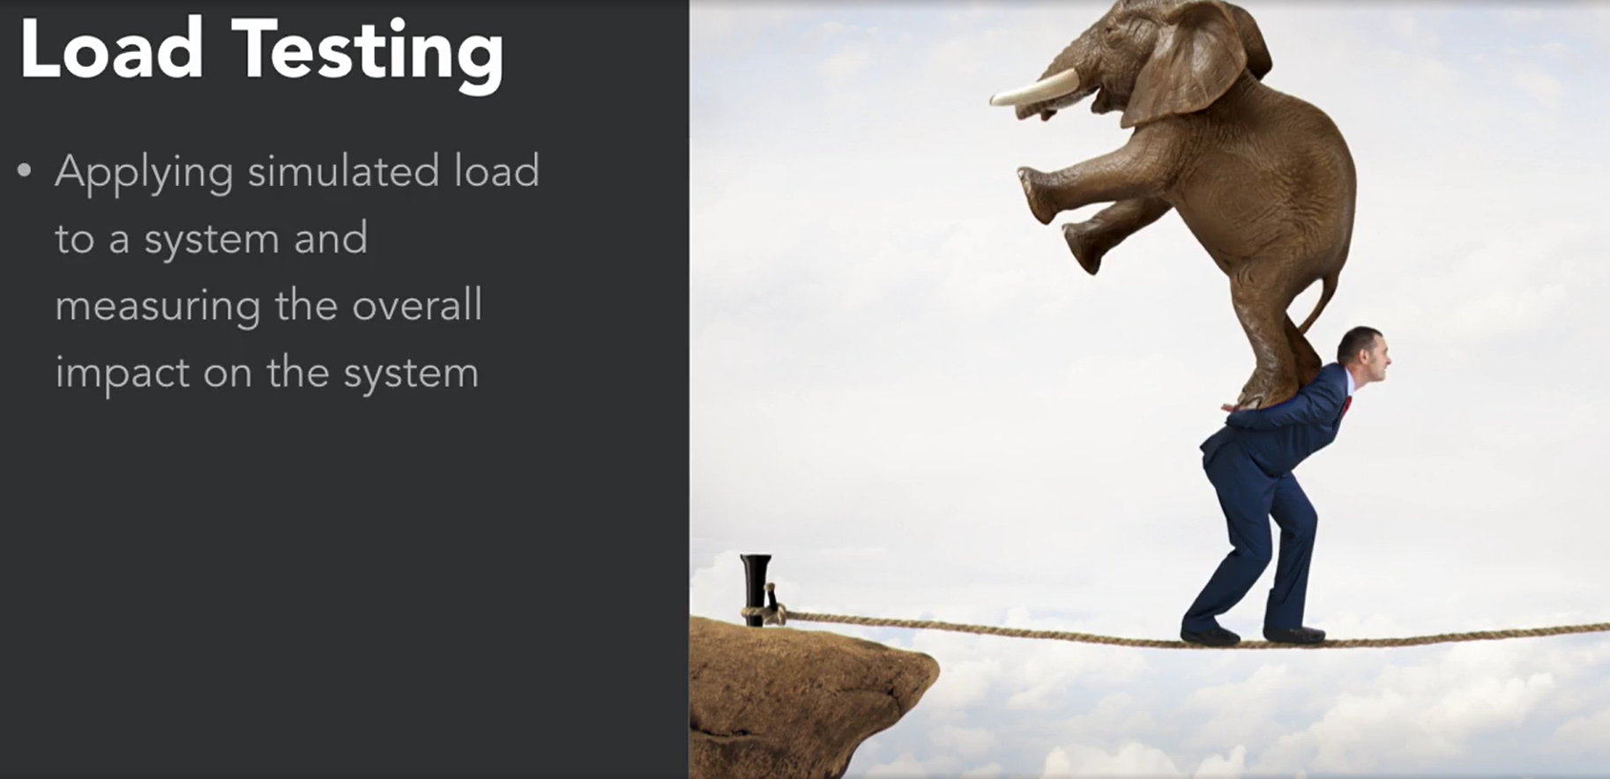

In the above img let say our app is an person n we are testing the ability of the person to walk so for test what we have given we are running the person on a rope on the mountain n given an extra load of elephant on the person. 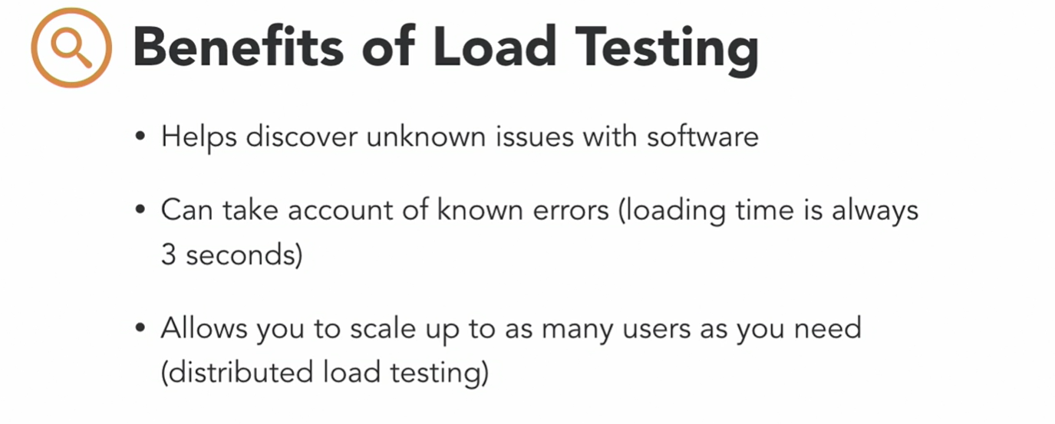



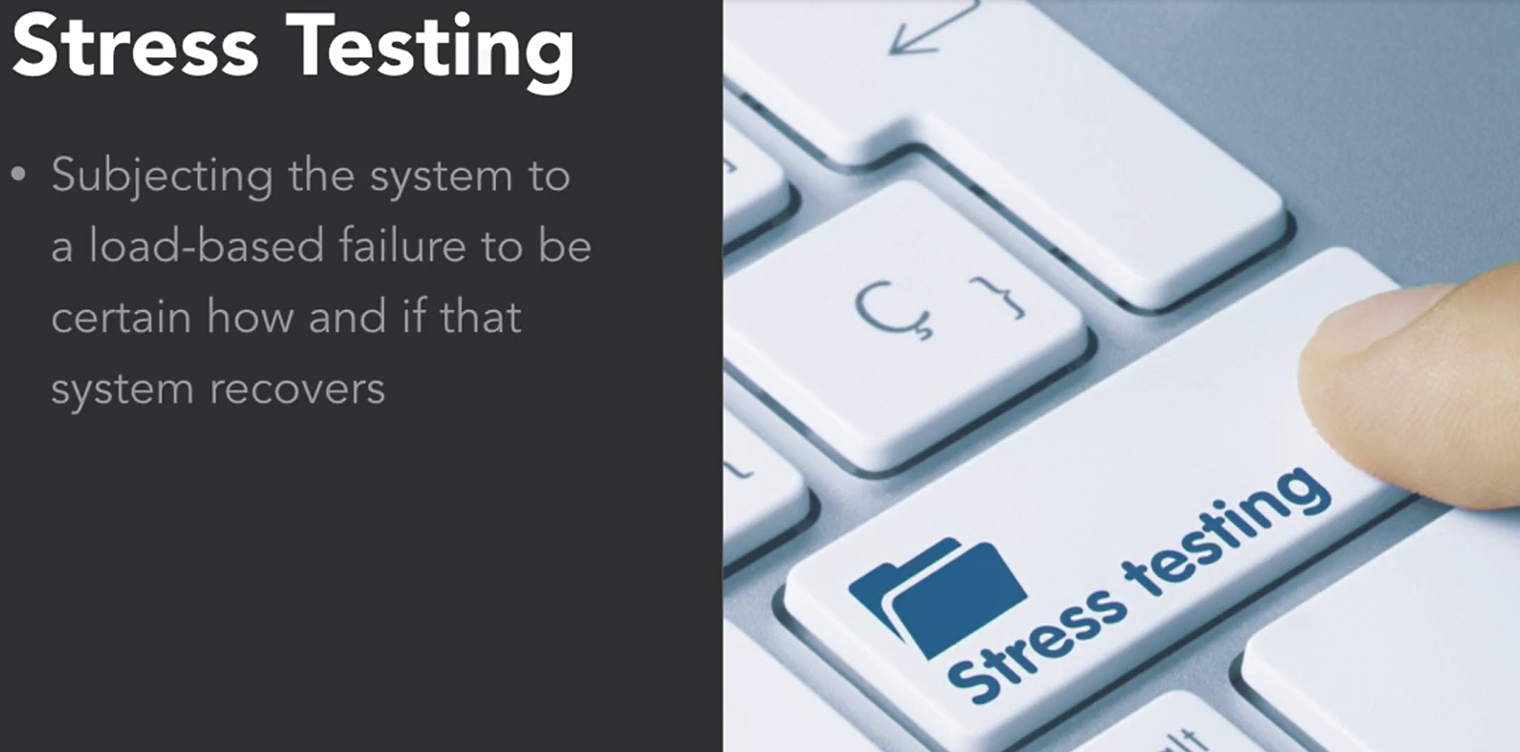

* Jmeter Setup:

1. Need Java (v 8+)
2. Need Apache Jmeter

To download java, [Download java](https://adoptium.net/en-GB/temurin/releases/?version=11) n extract the zip file n set the environment variables of jdk bin folder to path variable->once done open cmd n enter java –version if prompts with java version then good to go.

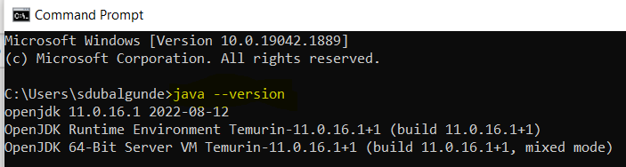

To download Apache Jmeter,go to [Apache Jmeter Download link](https://jmeter.apache.org/download_jmeter.cgi) ->select Binaries-> click on .zip link->once downloaded extract that folder into any location n go to bin folder n double-click on either jmeter.bat or Apachejmeter.jar file to run the jmeter

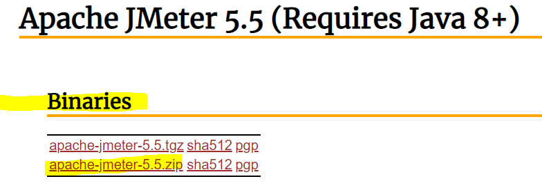

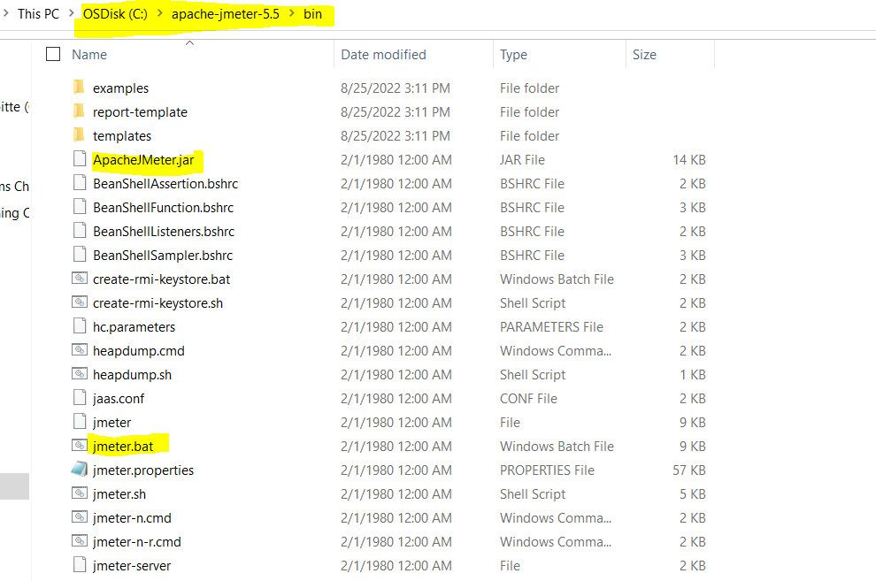

Once clicked on jmeter.bat file it will open a command prompt window n start running the Apache Jmeter application like below:

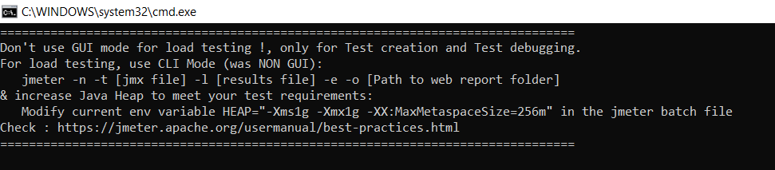

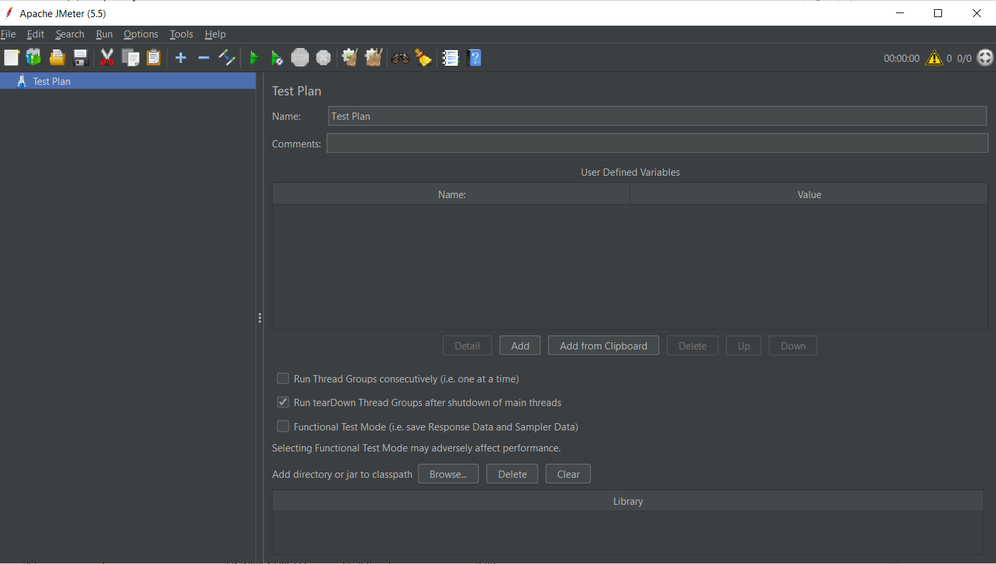

If we click on ApacheJmeter.jar file it will open an JMeter GUI only.

If we close any one window like cmd or apache jmeter window then both the window will get closed,so don’t close any window if you are sure that no other work is pending with Jmeter app.

* GUI Overview:





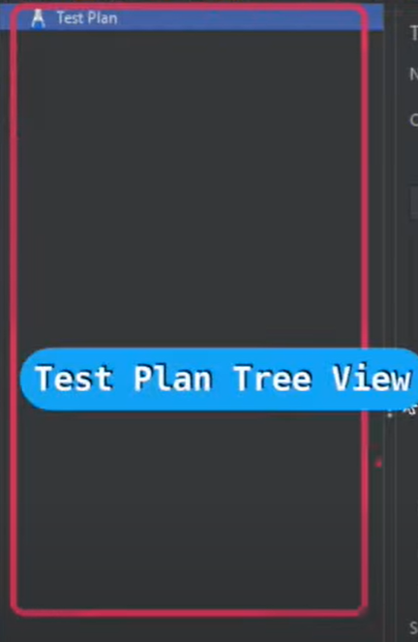

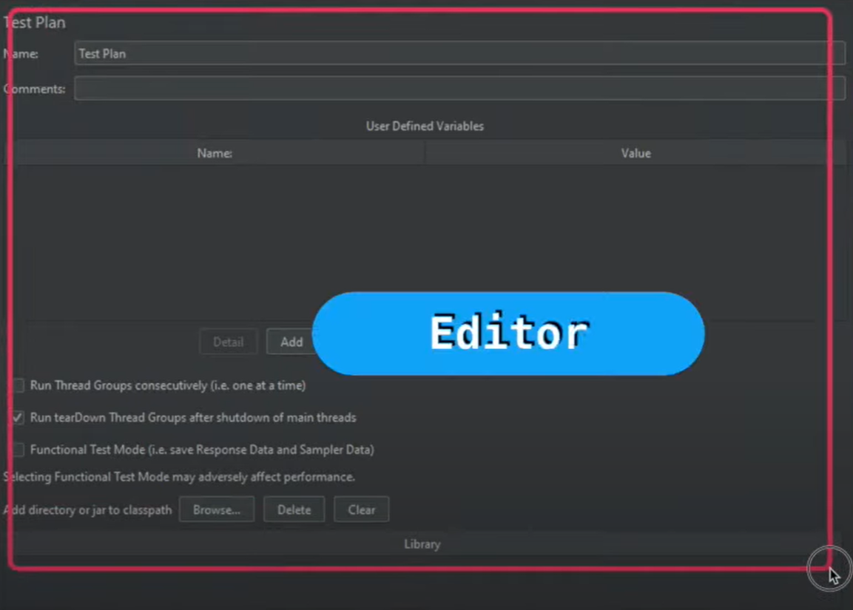

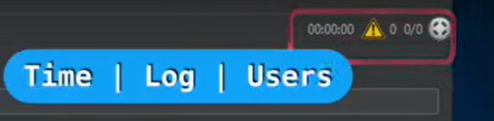



Main Tool Bar involves New(New Test Plan button),Templates,Open,Save,Cut,Copy,Paste,Expand All,Collapse All,Toggle(Enables or disables the component that is selected),Start,Start no Pauses,Stop,Shutdown,Clear,Clear All,Search,Reset Search,Functional Helper Dialogue Box,Help

* First Test:

To create your 1st test you need to follow below step

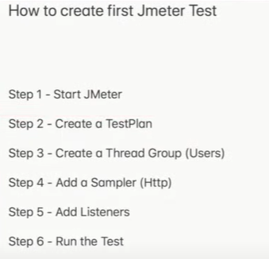

Step 1: Start Jmeter: you need to go onto the apache jmeter folder where u extracted(C:\apache-jmeter-5.5\bin) then double-click on jmeter.bat(It will open Cmd n Actual app) or ApacheJmeter.jar(It will open Actual app) file to Run the jmeter.

Step 2:Create Test plan: To create a new test plan,you can click on File menu->New->after clicking on New Test Plan will open you can save that test plan as you want .here I saved this as ‘First-Test.jmx’ where provided the name,description n we can describe the user-defined-variables like below img n which variables we can use inside this variables inside this ‘First-Test.jmx’ test plan.

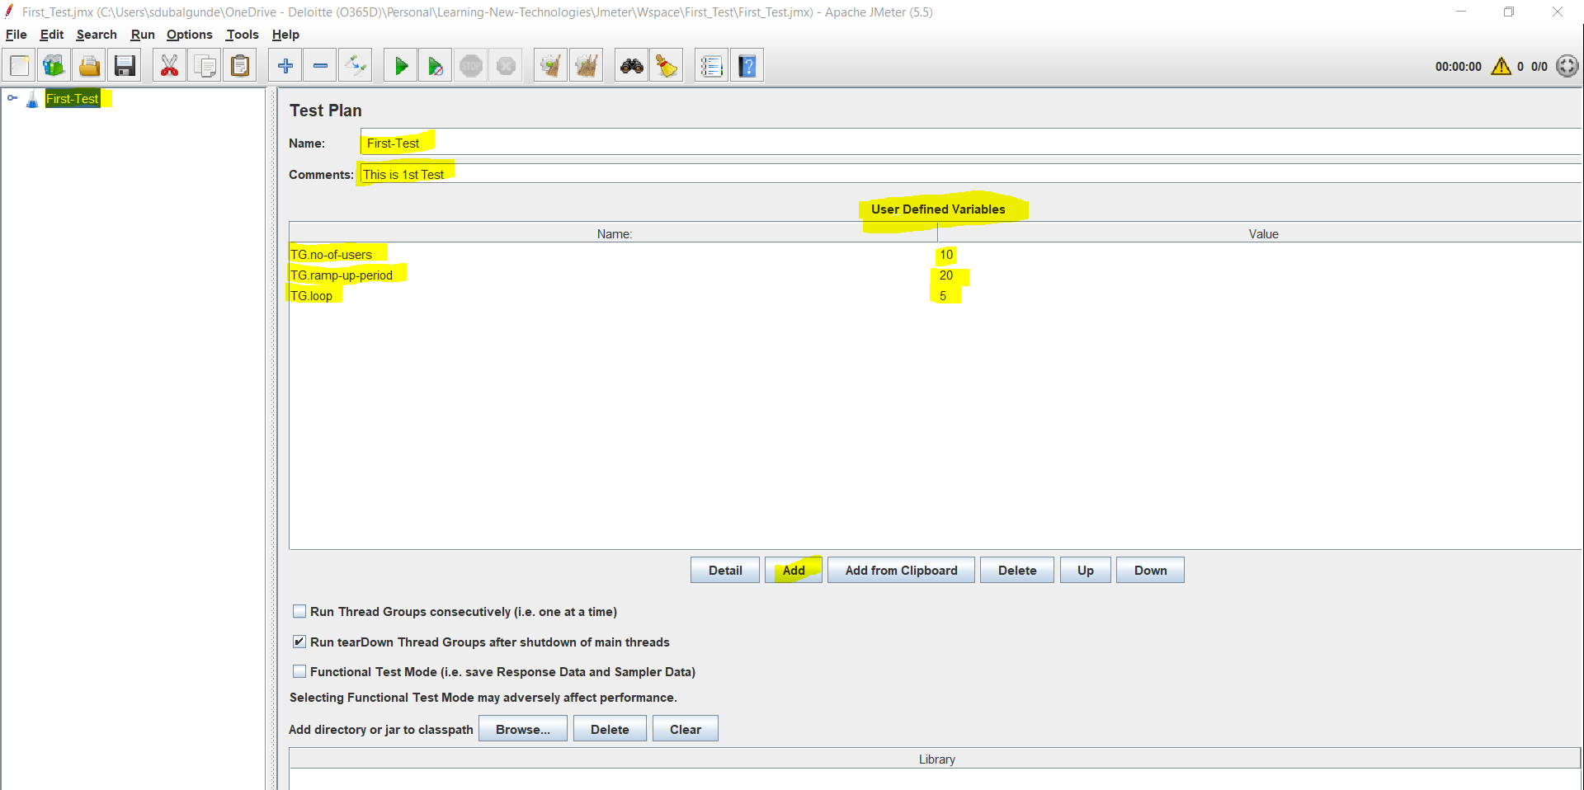

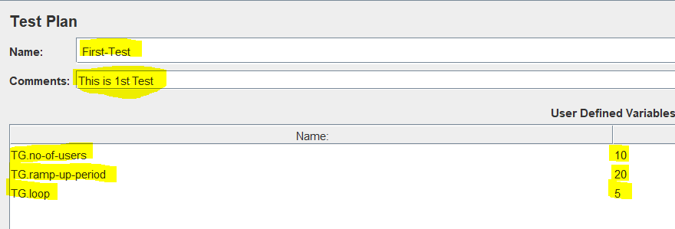

Test plan is a placeholder which can store the various components like Thred Group,Samplers,Listeners etc in it + we can declare the user-defined variables n that variables we can use inside the test plan.the syntax is:

${Variable_Name}

In the above screenshot,we declared 3 variables TG.no-of-users,TG.ramp-up-period,TG.loop here we used TG. Becoz to understand in which component we are using this variable(TG=Thread Group) for my understanding but we can define the variable as no-of-users, ramp-up-period,loop etc.



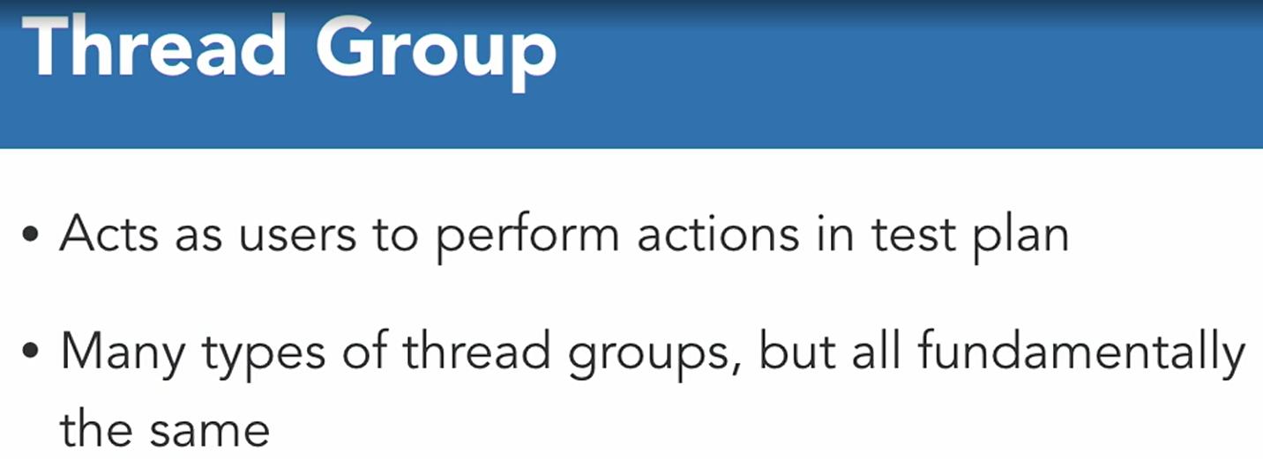

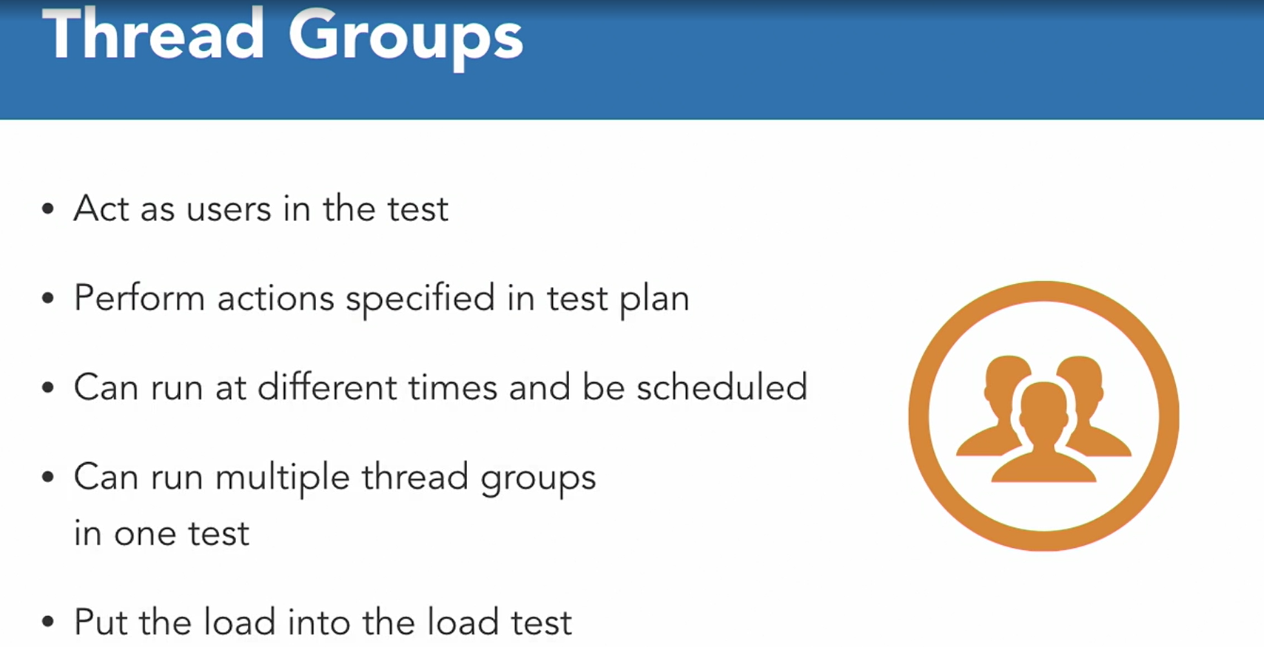

Step 3: Create a Thread Group(Users):We need to add the thread(user) who will test the load n performance so for that we need to add Thread group by :

Go to Test Plan in Test Plan Tree View->Right Click n select Add->Thread(users)->select Thread Group.

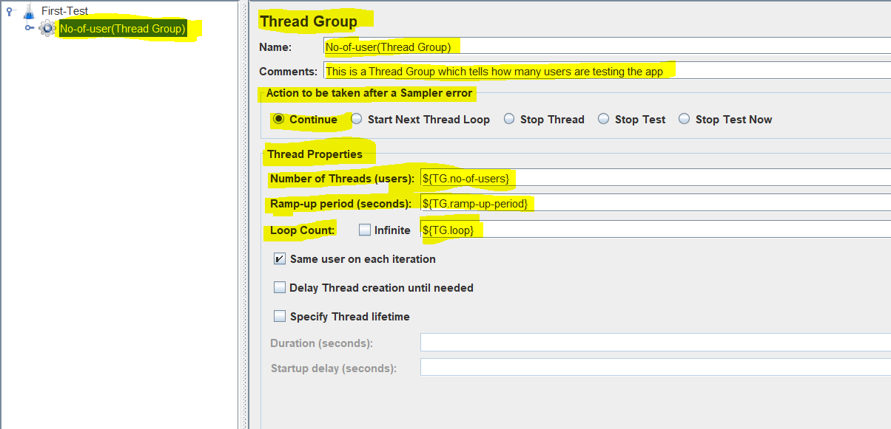

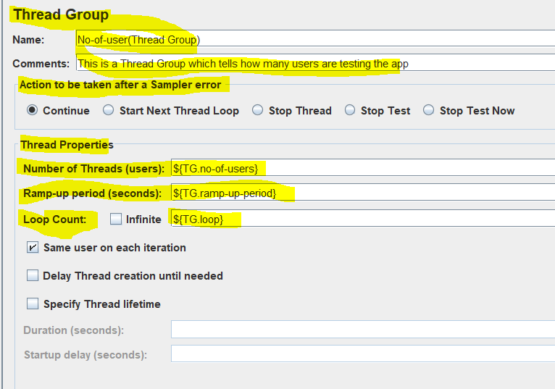

Thread Group is a component which is used to define the total no of users are used for this testing we can specify the ramp-up period n the loop count as well.

In the above case we used user-defined -variables n that variables values we used

${Variable_name}

Here we can see we have option Action to be taken after sampler error which means what to do after we get any test request that is get failed,

options are Continue,start next thread loop,stop thread,stop test,stop test now.

Sampler means Request

We have no of threads(users),ramp-up-period(seconds) n loop-count(infinite or number)

Let say we keep

no of threads(users)= 1

ramp-up-period(seconds)=1

loop-count(infinite or number)=1

ramp-up-period(seconds)/ no of threads(users)=1/1=1 sec me new user will be added

sample count= no of threads(users)* loop-count(infinite or number)=1*1=1

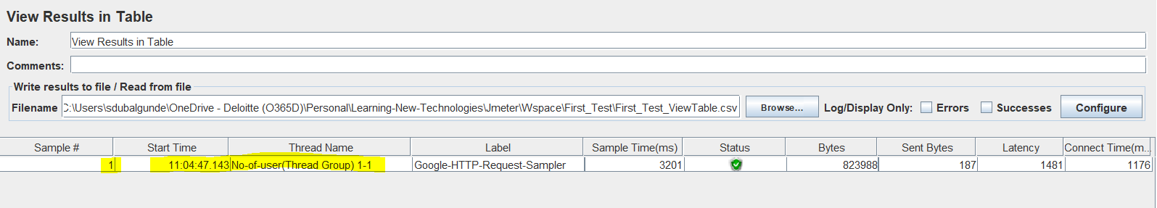

If no of threads(users)= 10

ramp-up-period(seconds)=1

loop-count(infinite or number)=1

ramp-up-period(seconds)/ no of threads(users)=1/10=0.1 sec me new user will be added

sample count= no of threads(users)* loop-count(infinite or number)=10*1=10

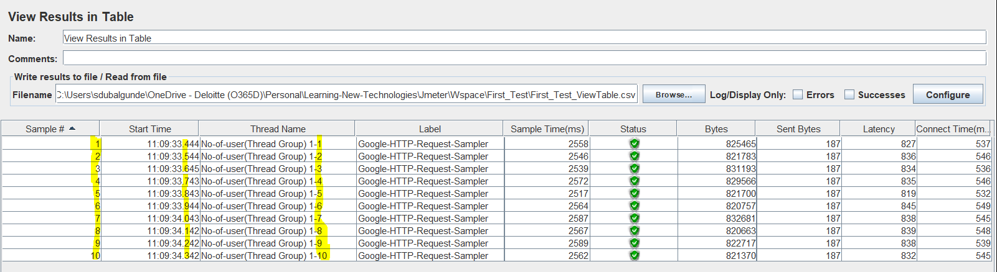

If

no of threads(users)=20

ramp-up-period(seconds)=10

loop-count(infinite or number)=1

ramp-up-period(seconds)/ no of threads(users)=10/20=0.5 sec me new user will be added

sample count= no of threads(users)* loop-count(infinite or number)=20*1=20

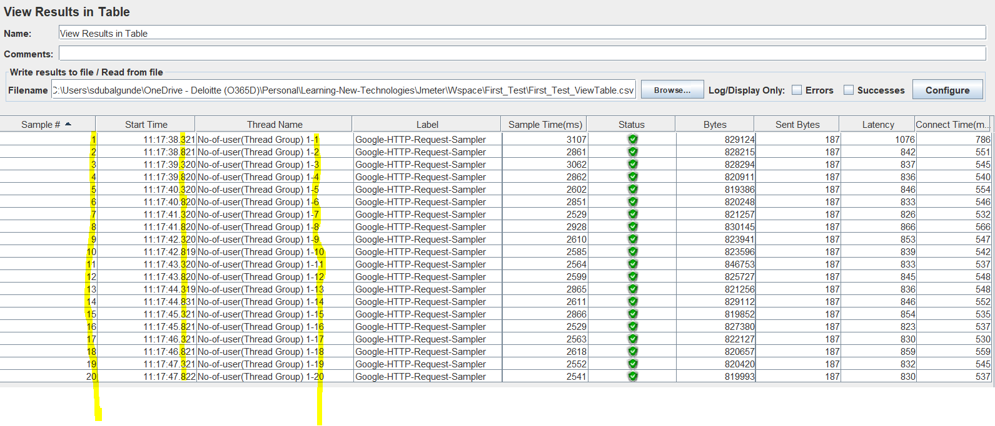

If

no of threads(users)=20

ramp-up-period(seconds)=30

loop-count(infinite or number)=1

ramp-up-period(seconds)/ no of threads(users)=30/20=1.5 sec me new user will be added

sample count= no of threads(users)* loop-count(infinite or number)=20*1=20

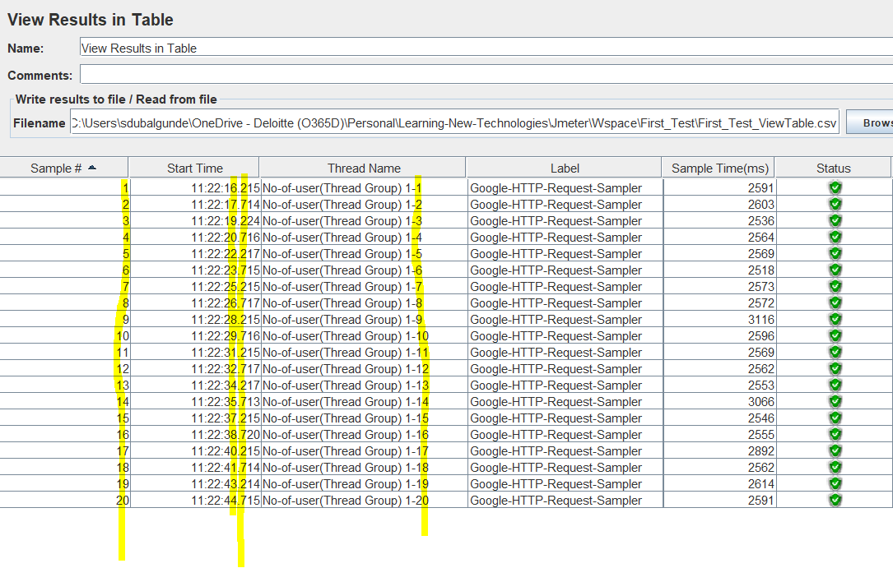

If

no of threads(users)=20

ramp-up-period(seconds)=30

loop-count(infinite or number)=2

ramp-up-period(seconds)/ no of threads(users)=30/20=1.5 sec me new user will be added

sample count= no of threads(users)* loop-count(infinite or number)=20*2=40

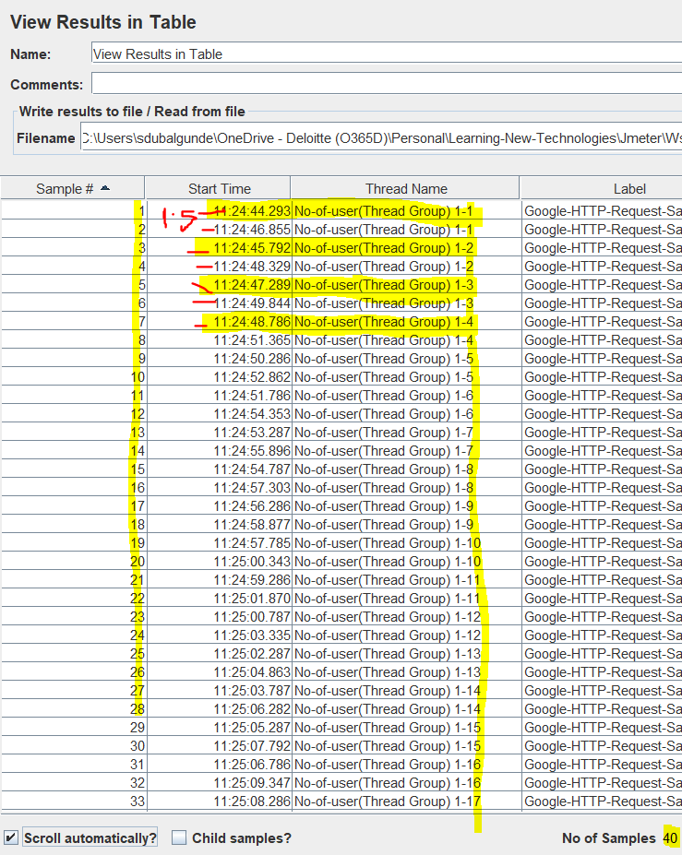

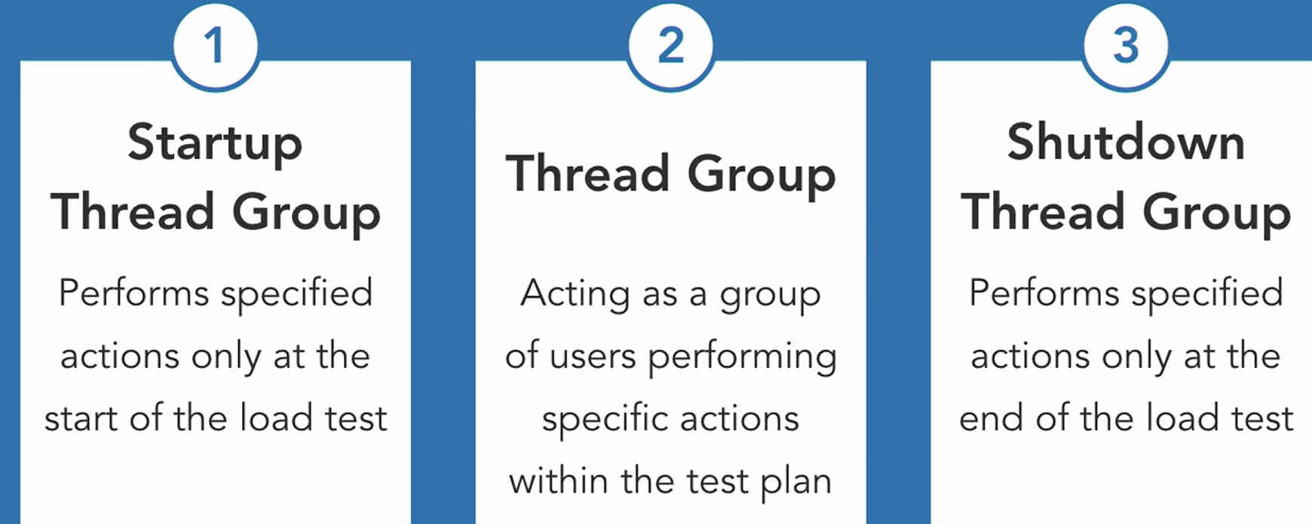

Step 4:Add a Sampler(HTTP) : once we configured the Thread Group then we need to add a Samplers(Test Request) there are so many requests like HTTP request,tcp samplers,jms publisher,junit request etc.



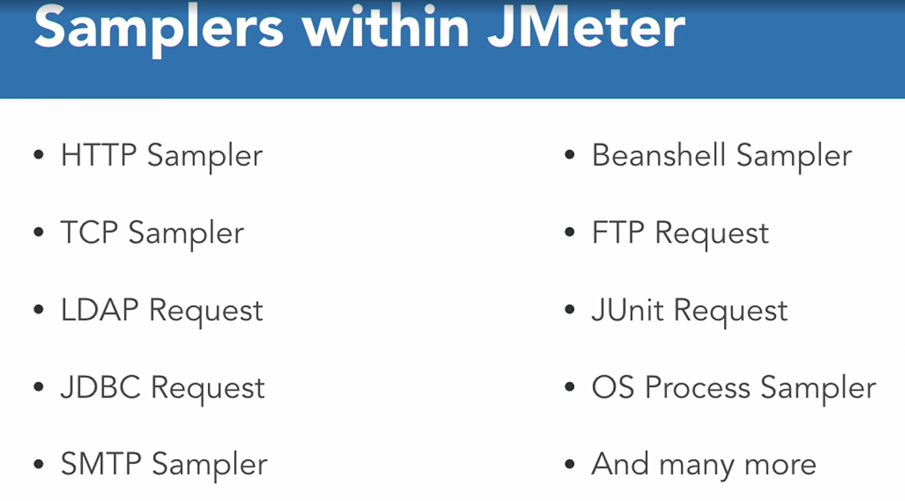

To add Samplers, Right click on Thread Group added->select Add->select Samplers->select one of the sampler(HTTP,TCP,JUNIT,JMS etc.) 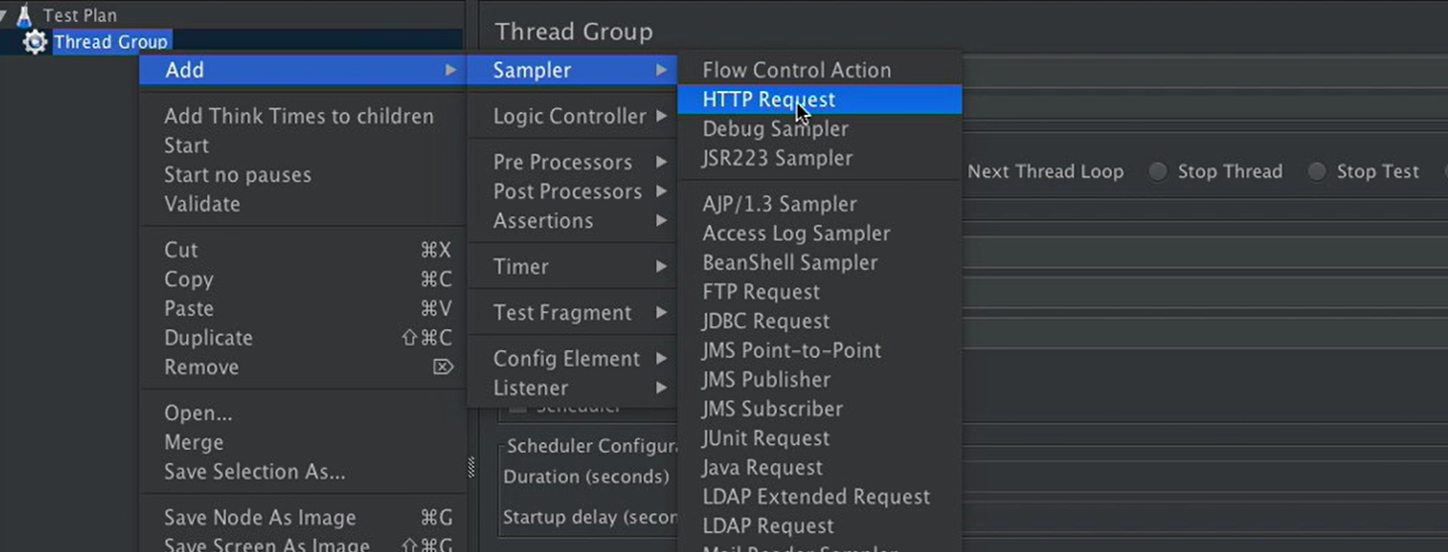

In this case added HTTP Request as a sampler in below screenshot:

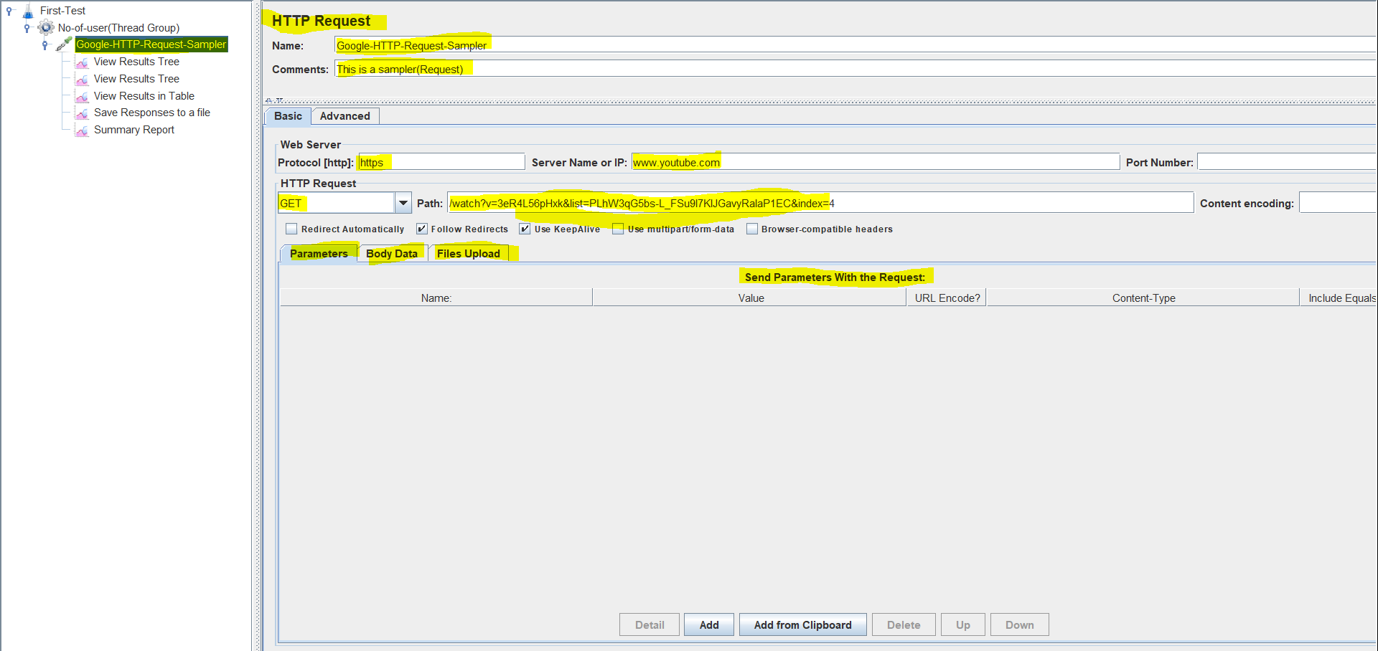

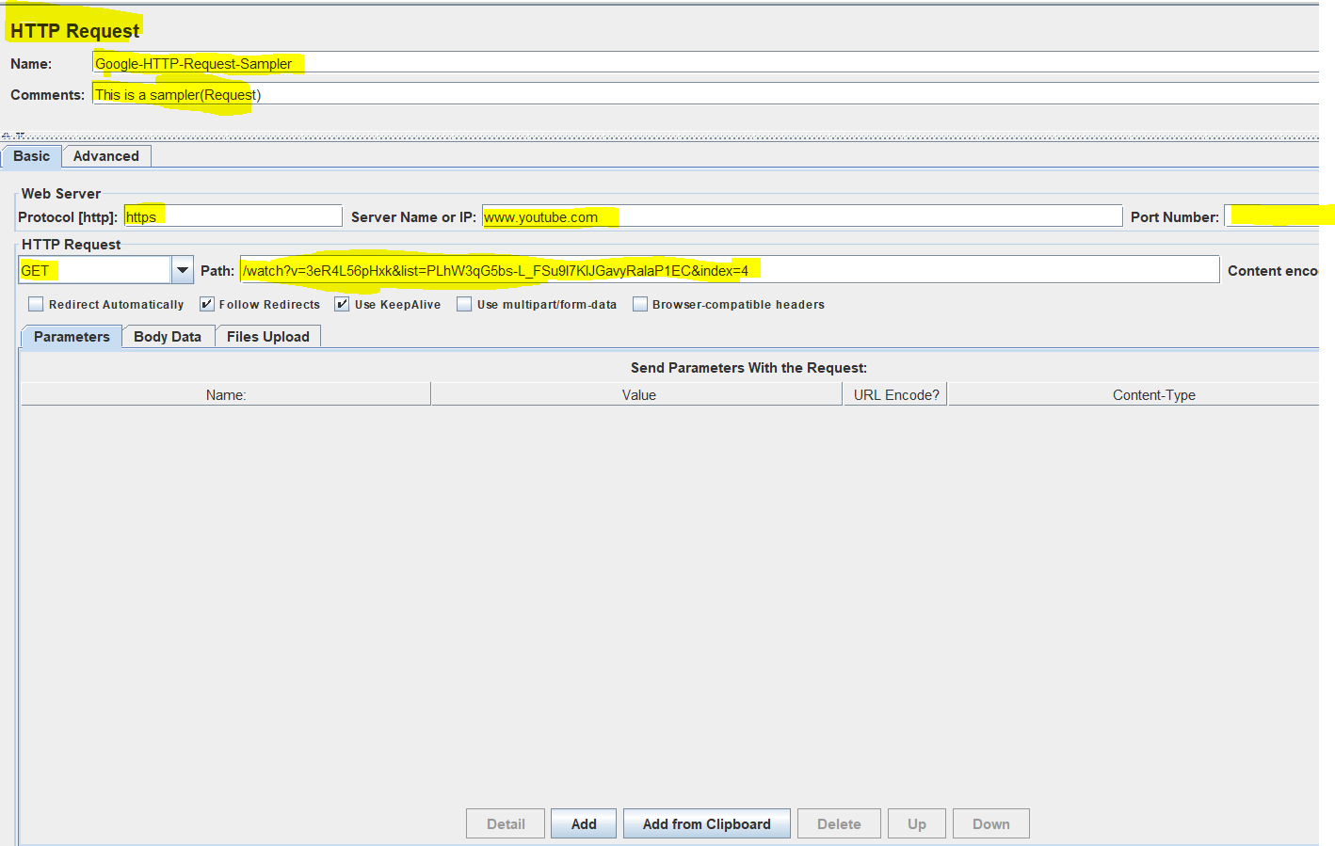

In HTTP Request we have to provide a name,description,protocol(http/Https),server name/ip(website domain name),port number(if any),HTTP Method(GET,POST,Patch,Delete),Path(Path can contain the webpage url)

In above image you notice that in path field we have given the path as well as we have given queryparams also so if we want we can separately declare queryparameters in parameters section n if we have some body to be sent with request then w can use Body Data as well.

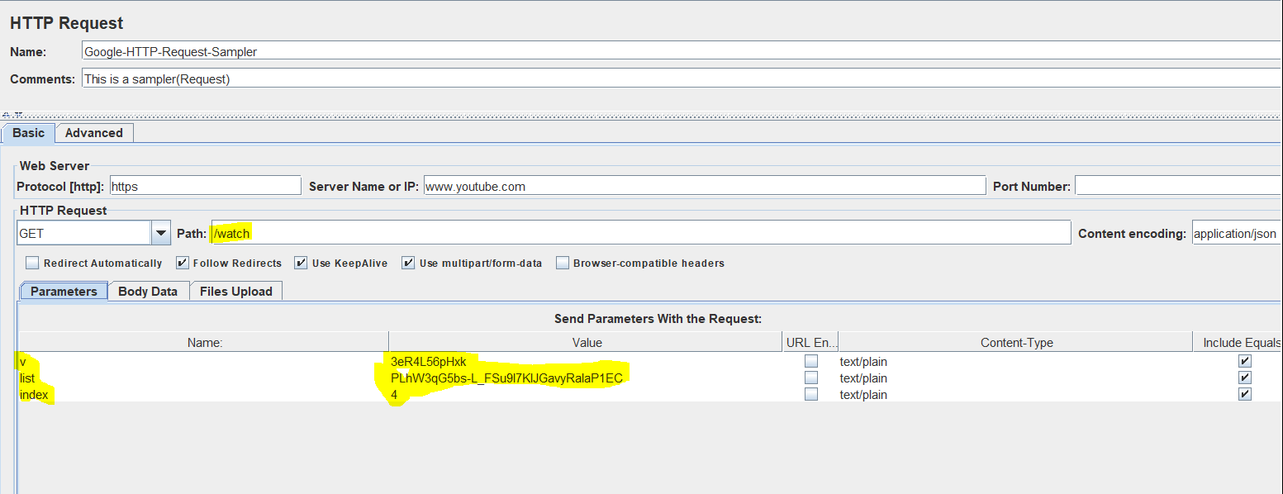

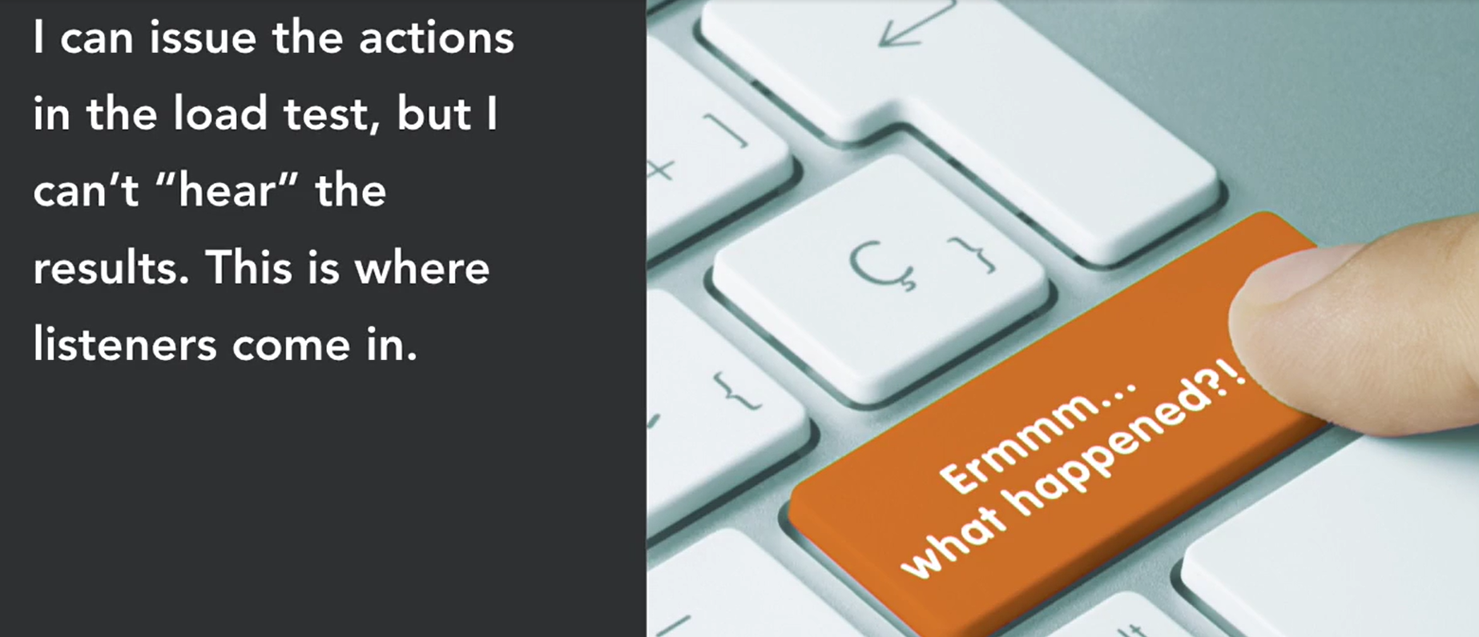

Step 5: Add Listener: To grab the Test Results we can use various Listeners that Jmeter provides like View Result Tree,View Results in table,Save response to a file,Summary report of test etc.

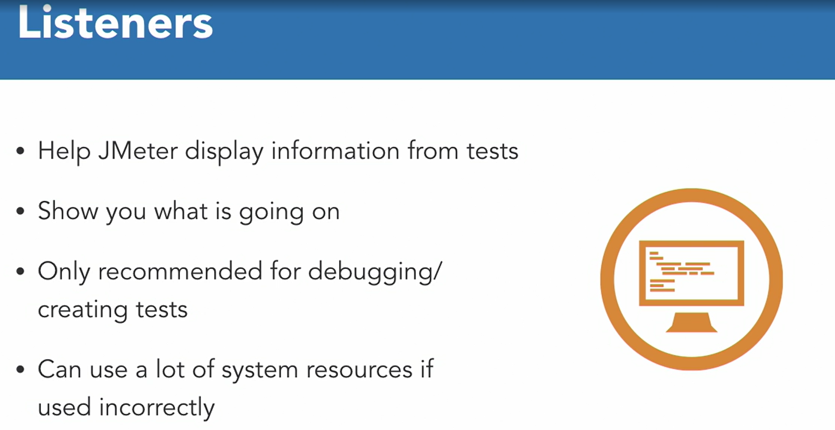

To add listener, Right Click on Sampler->select Add->Select Listener->Add listeners that you need (View Result Tree,View result in table,Summary report etc. 

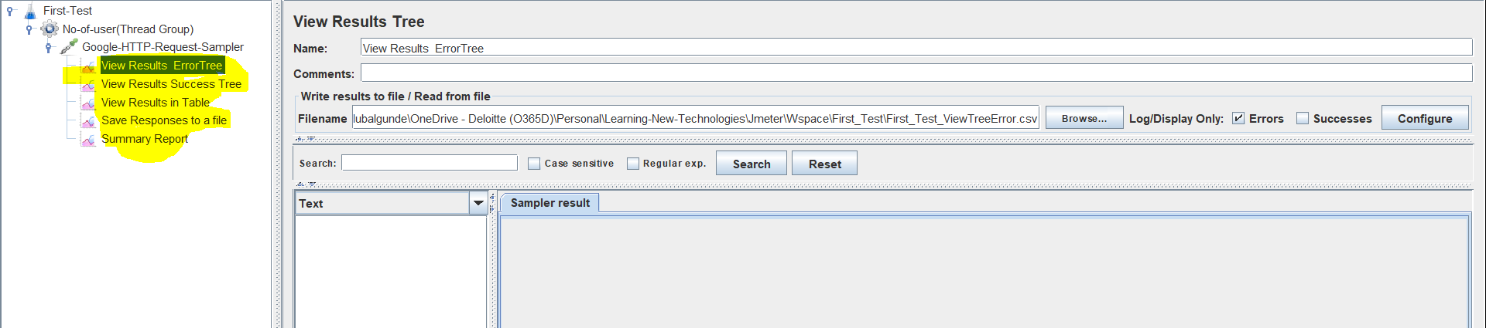

In above img we have added View Result Tree,View result in table,Summary report n Save response to a file .

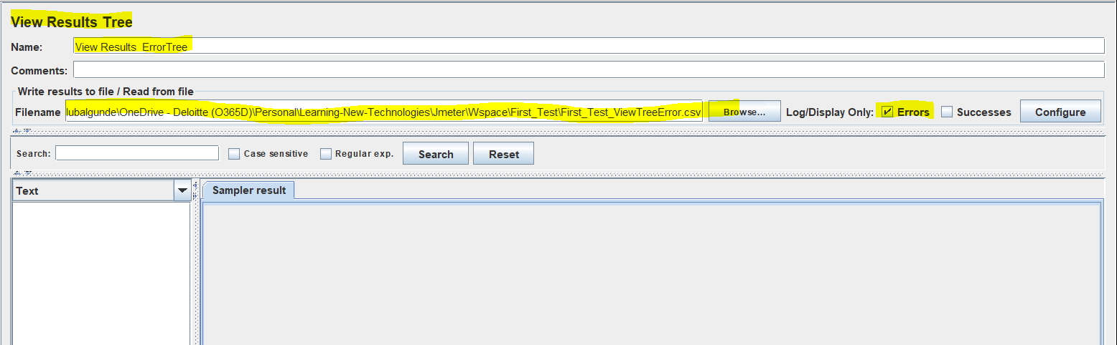

In the above img we have added view results tree where we are capturing only the errors in a file n this file stores all errors responses.

To give a path of file to save error response ,we need to click on browse n then need to select a folder in which we need to create a file which will store the result(At starting When Jmeter runs It will create a file n add the data but if what if file is already there then jmeter will ask us to append the data or do not start the test or Overwrite the Data in file.)

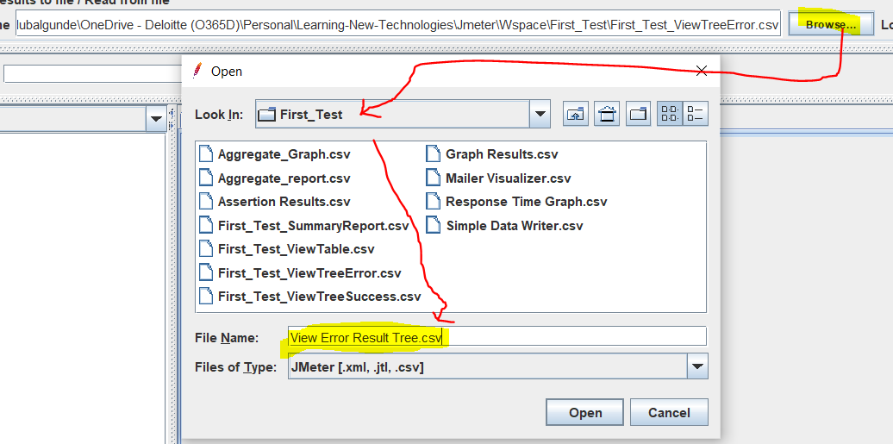

First time if we locate path n give name to file .csv it will give an error after clicking on Open,

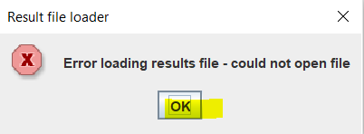

Just ignore this error n run the test it will create the file automatically.

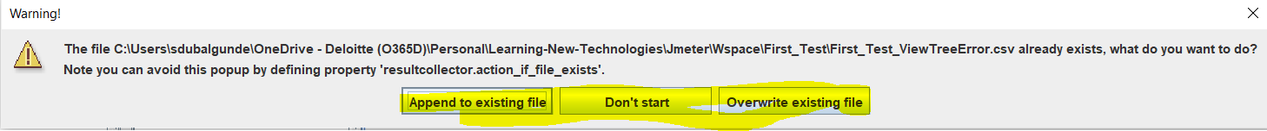

We can overwrite the file so that only new data will be present in the file.

It is recommended that we should give .csv as file format becoz they are easy to read.

Step 6: Run The Test: after we done with all the configuration we need to run the Test Plan.To run the Test Plan we can select Start Button

If we have configured any local filepath in listener n they are already existing then we will get the below warning



Select what do you want n then test starts executing.

While running the test plan Run button gets disable n then stop the execution n shutdown button gets enabled automatically.

Once test execution gets over we can see the results in listeners that we configured

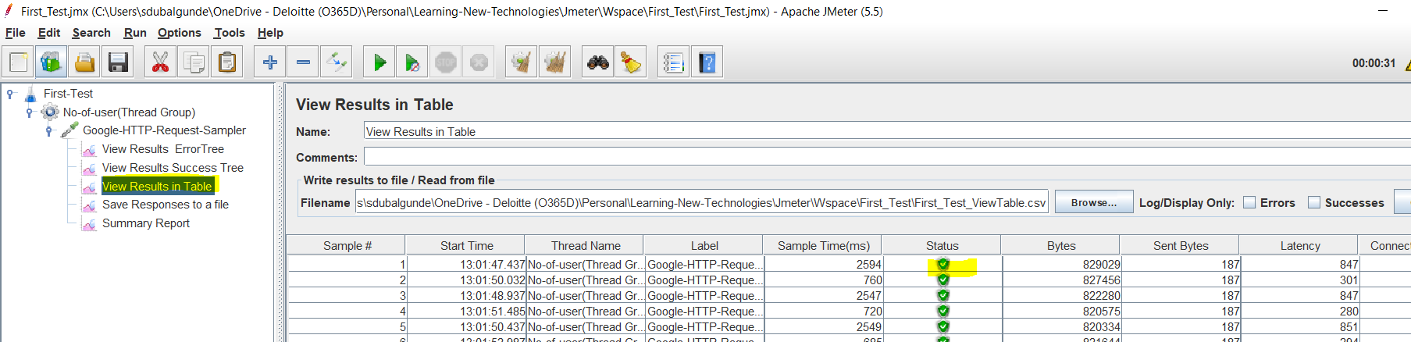

Once we see the result in listeners ,we can clear the results of selected listener or result of all listener at same point by clicking on Jhadu button(Clear or Clear All)

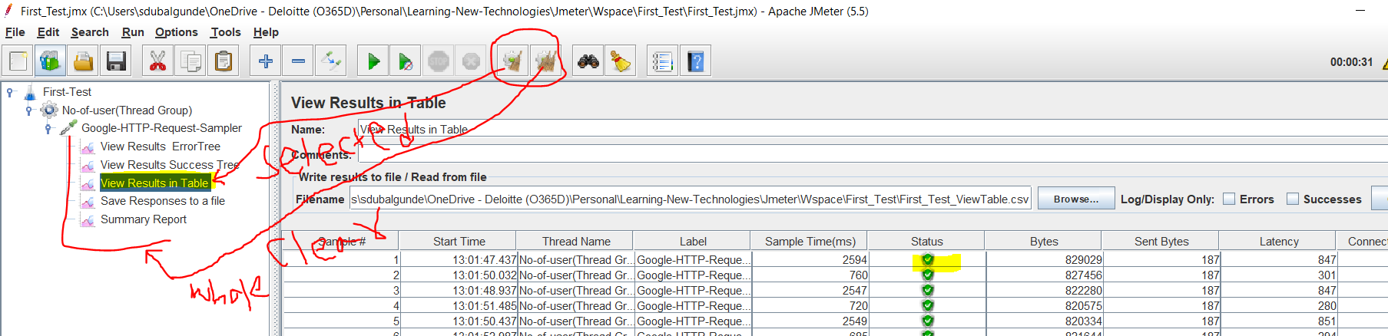

* JMeter Listeners

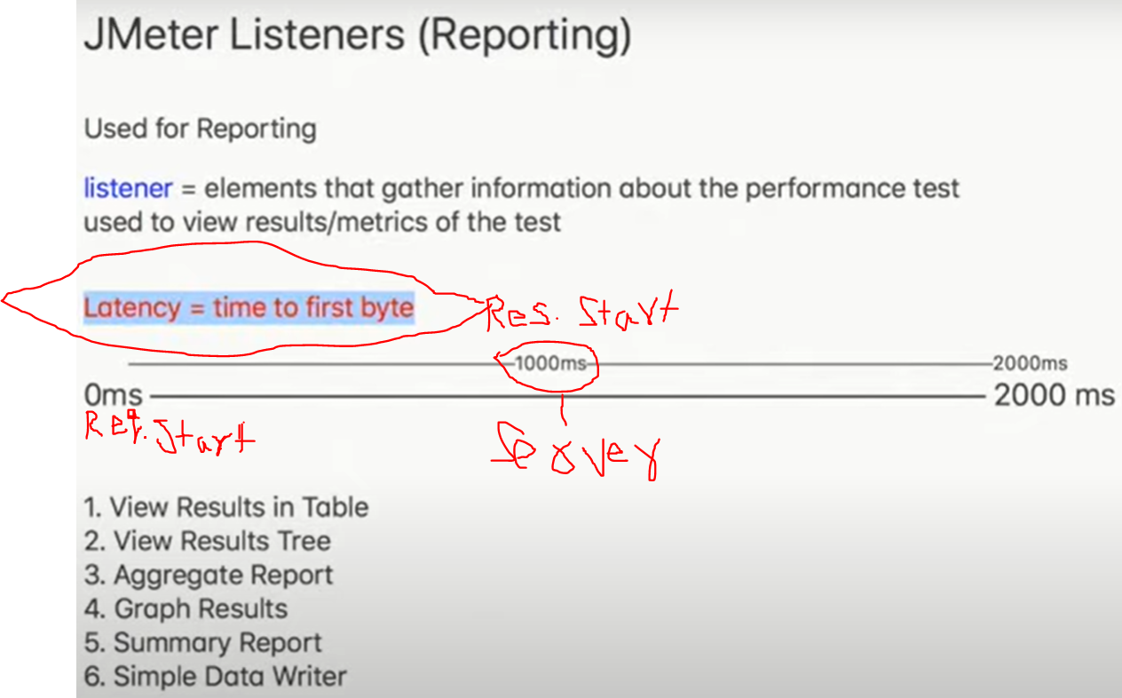

Latency is a time of response started (time taken to send first byte of response to client)

View result Tree:

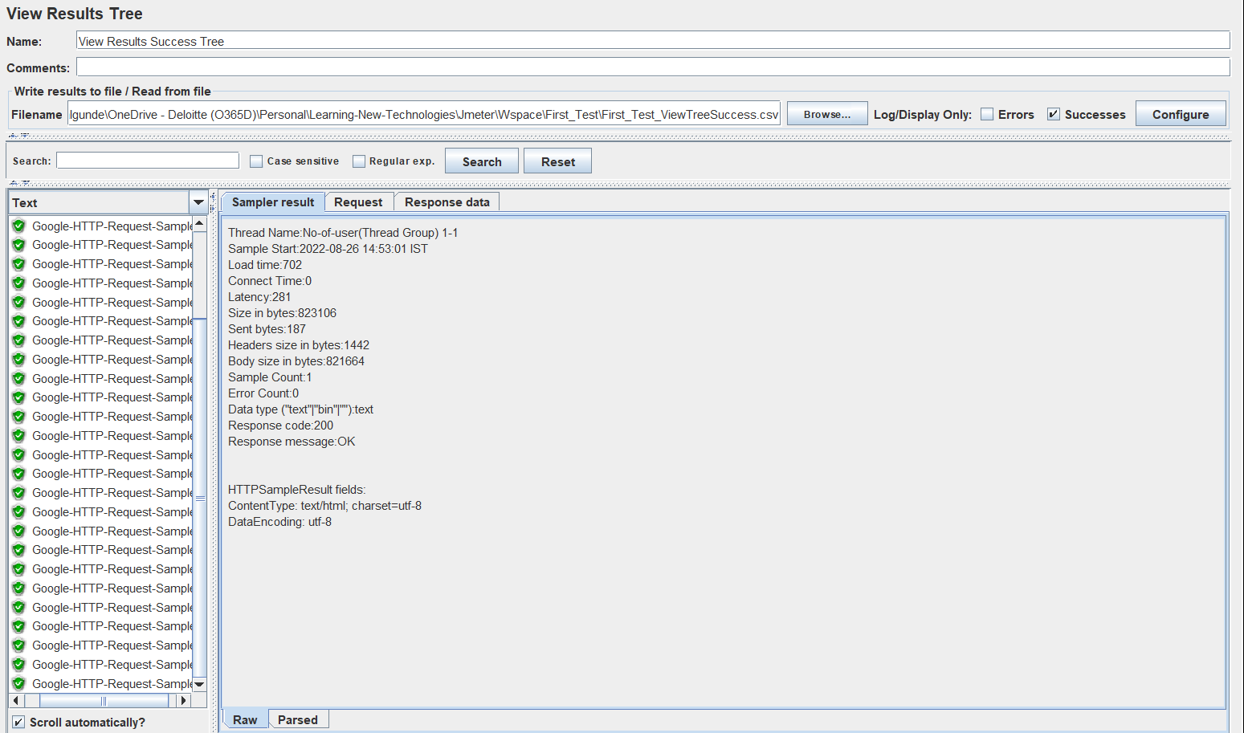

View result in Table:

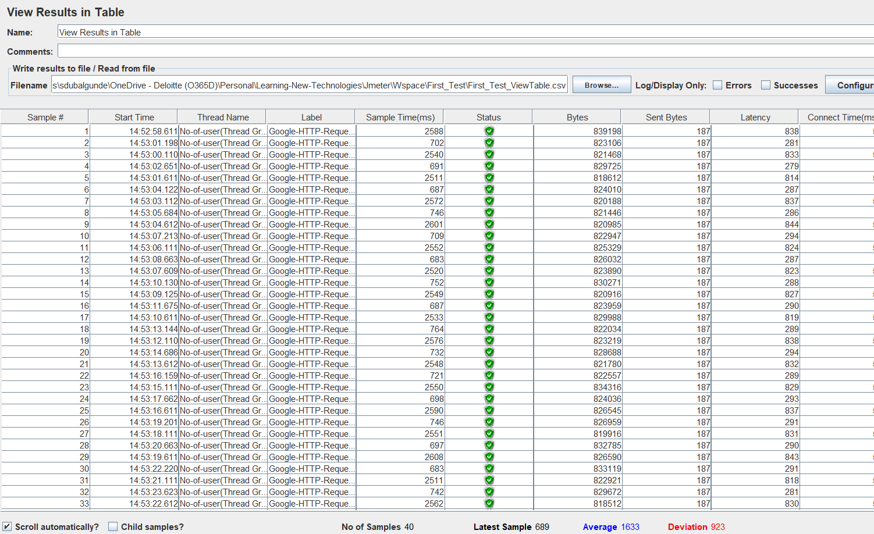

Summary Report:

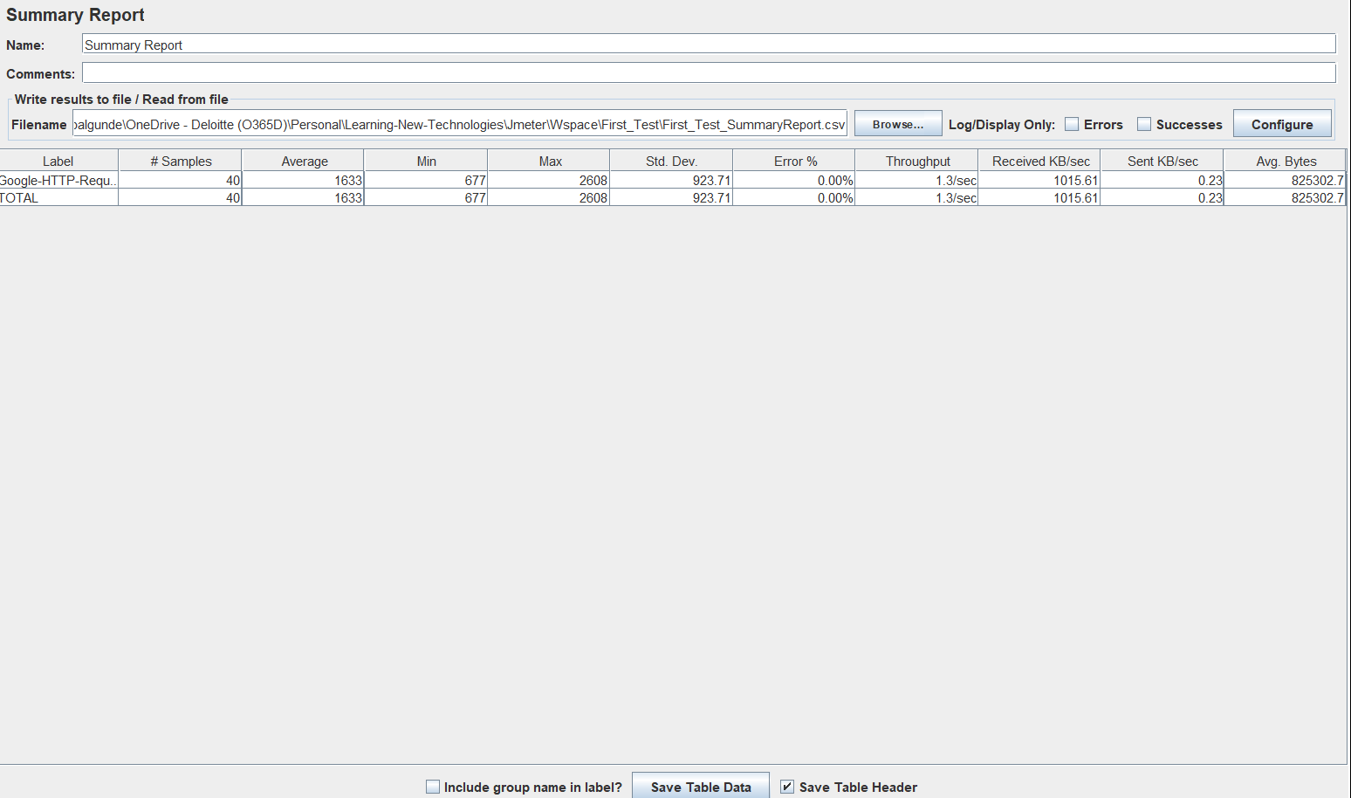

Graph Results:

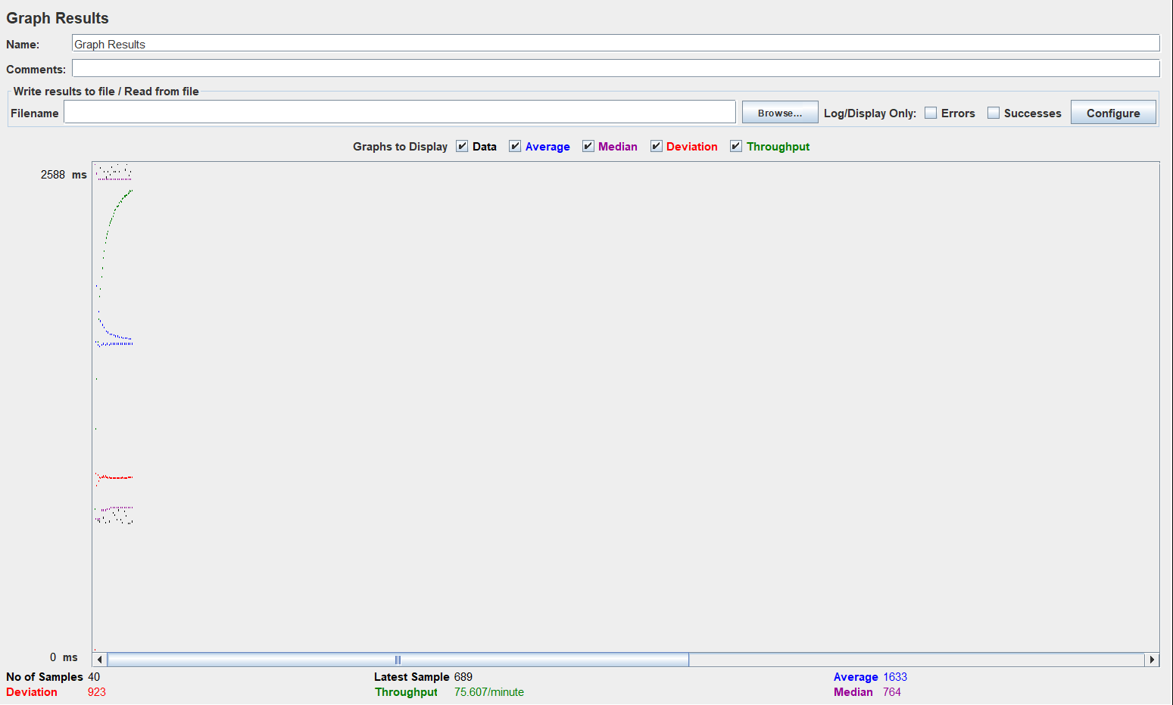

Simple Data Writer: 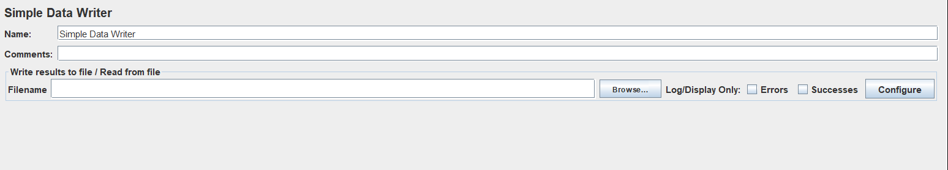

Aggregate Report: 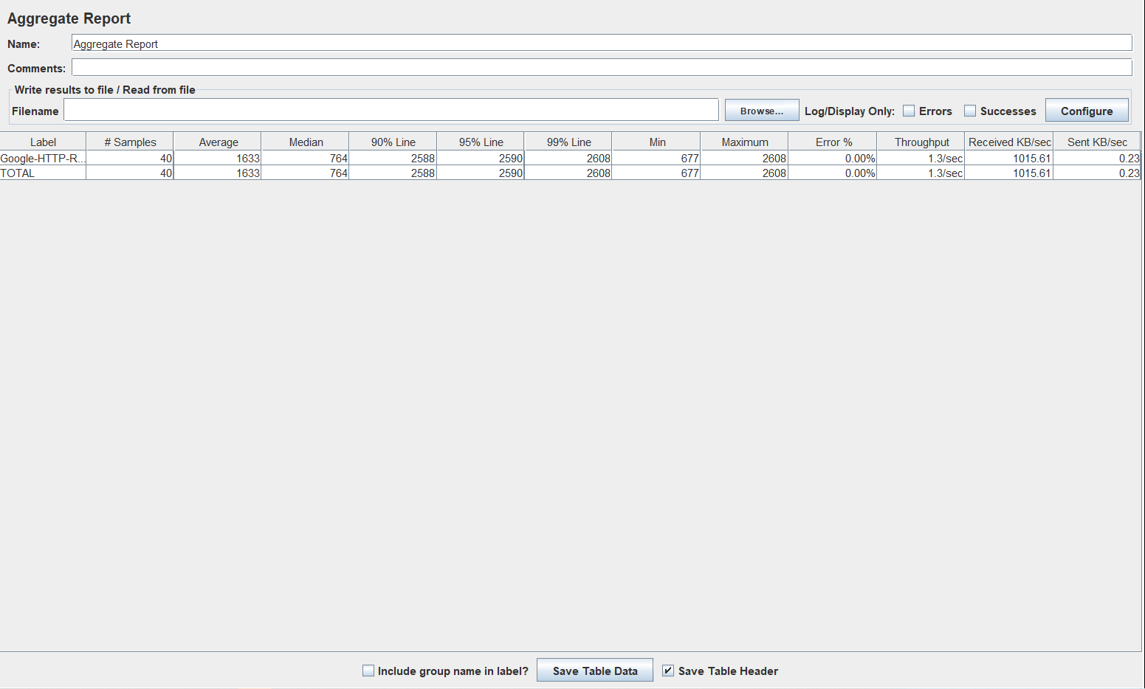

Assertion Result:Provides response of assertinos if configured

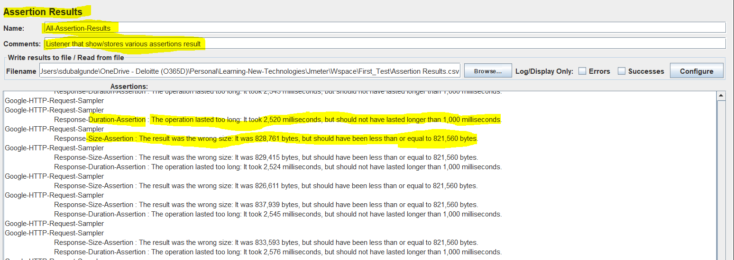

Toggle button 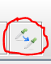 or Enabling/Disabling the component:

To enable or disable the component u can select that component n then u can right click n select Disable/Enable command.

Or you can select the component n click on toggle button if ur component is enabled then clicking toggle button result in disable the component n vice-versa.

* Assertions:means testing whether we sent/received proper request/response to/from server.We have assertions which checks:

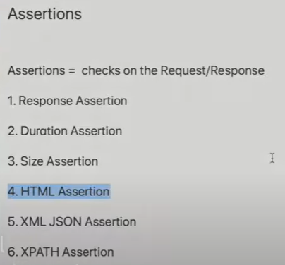



We can declare the assertions at @Test Plan level or @Thread Group Level or @Sampler Level.if defined at @sampler level then can be used inside the sampler only if defined @Thread Group level then can be used inside the Thread group.

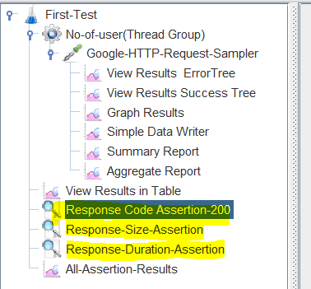

1.Response Assertion: Checks the response code,message,request/response headers etc.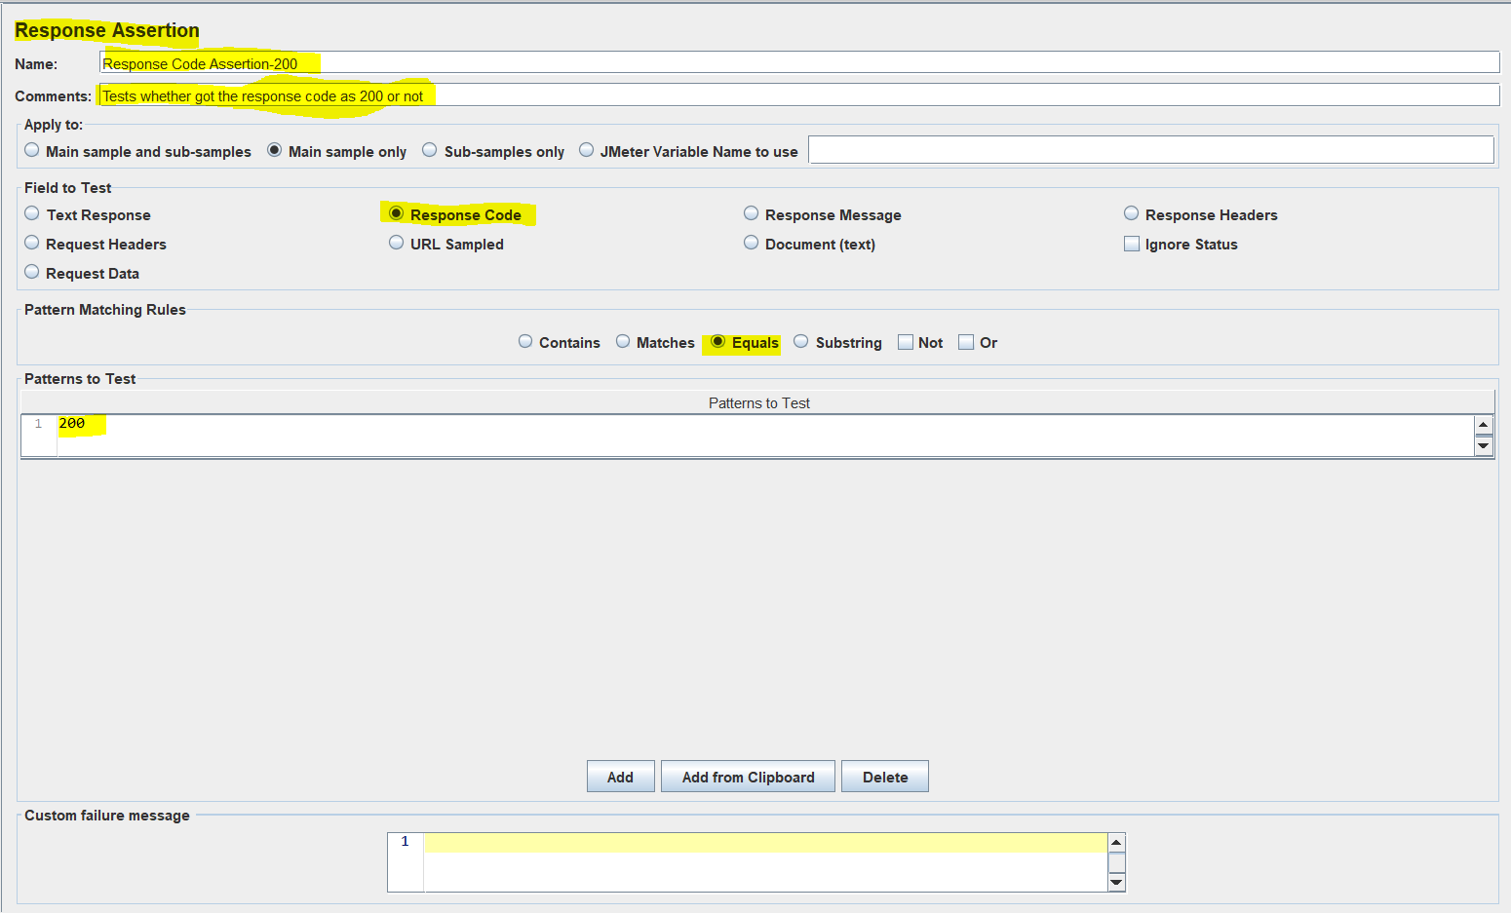

2.Size Assertion:Checks the response size

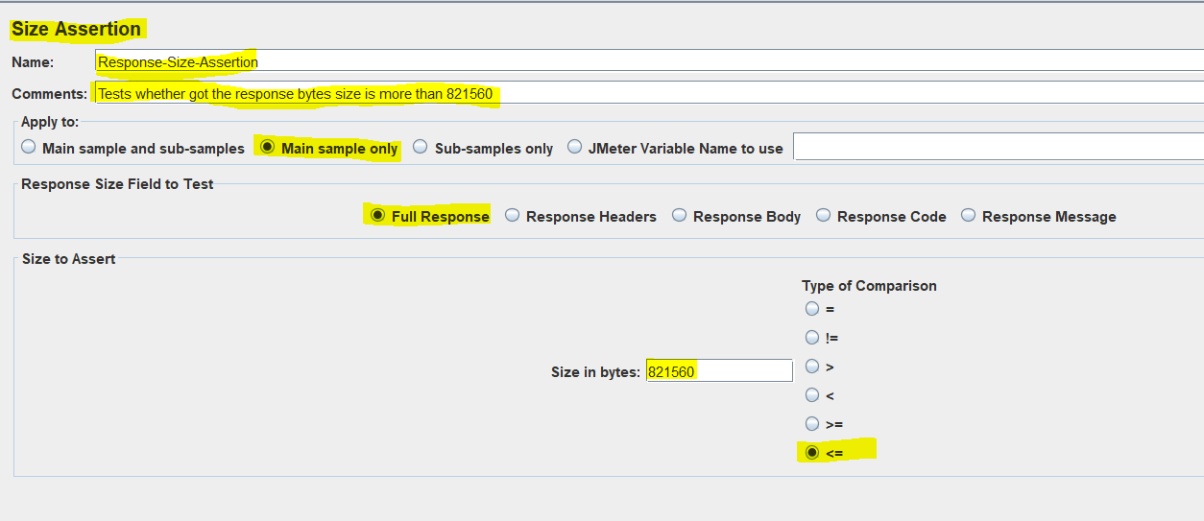

3.Duration Assertion: Checks for Response time

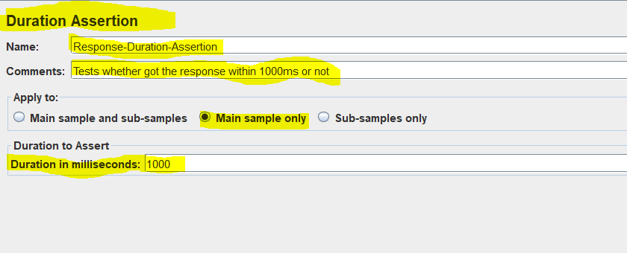

* Jmeter Http(s) Test Script Recorder:This functionality is used to record the tests .

To use Jmeter Http(s) Test Script Recorder we have to click on Test-Plan level n then->Add->Select Non-Test Elements->Http(s) Test Script Recorder.

Then need to add Thread Group

To configure the Test Script Recorder we need to add logic controller(Recording Controller) to add this we need to right click on Thread Group->Add->Logic Controller->Recording Controller

[Youtube Link for learning about Jmeter’s Http Test Script Recorder](https://www.youtube.com/watch?v=voYj16cETAM&list=PLhW3qG5bs-L_FSu9I7KlJGavyRaIaP1EC&index=7)

* BlazeMeter Recorder:It is a cloud based Testing tool which is used for API Testing,Load Testing,Performance Testing etc.We can create the test n save those test as jmx so that we can use that test in jmeter .

[Youtube Link for learning about Blazemeter and how to use blazemeter to record Jmx Test n use those in Local JMeter](https://www.youtube.com/watch?v=vNZIDuhcujA&list=PLhW3qG5bs-L_FSu9I7KlJGavyRaIaP1EC&index=8)

* Config Elements

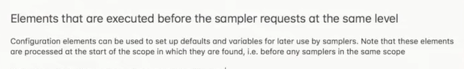

How to get data from CSV file using :

Csv Data Set Config is a component listed under config element which is used to get the data from csv file to configure the sampler(Test Request).This component gets loaded before the Sampler gets triggered in a test plan.

To configure CSV Data Set Config,select Test-plan/Thread Group/Sampler Right Click n select Add->Config Element->Csv Data Set Config.

For this to work we need to have a CSV file defined with data and the Sampler which uses this CSV Data Set Config

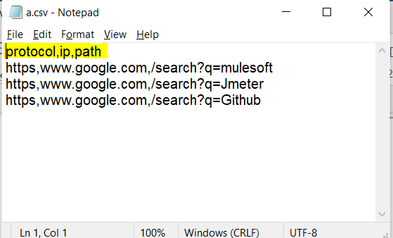

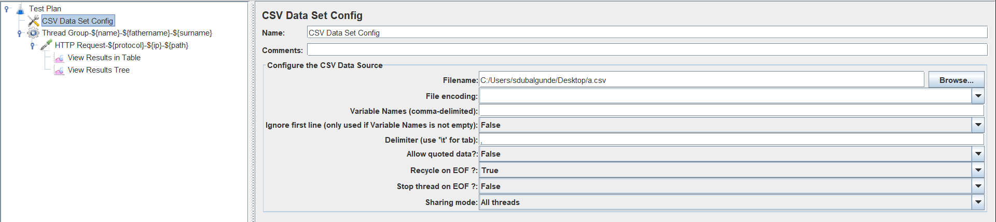

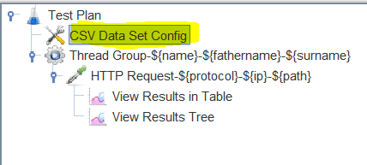

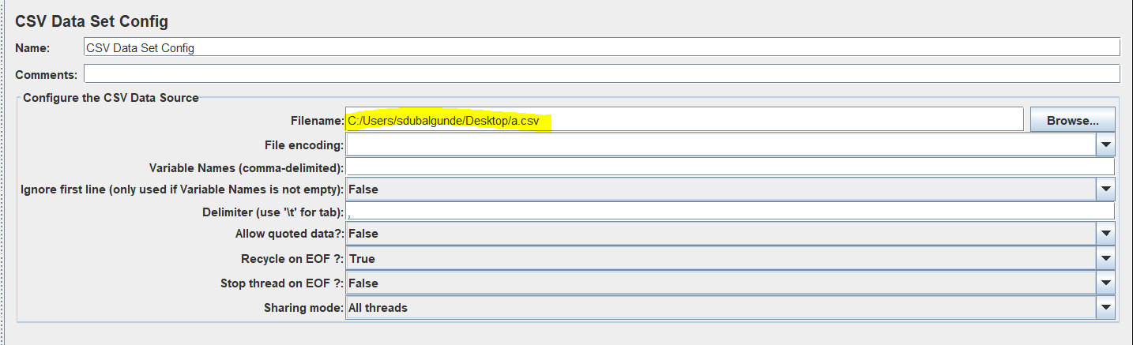

Here we defined the CSV data file with data like protocol,ip,path which are used to configure the Sampler-HTTP Request like below: Note that to access the data from csv file we need to use below syntax

${coulmnheader_nm}

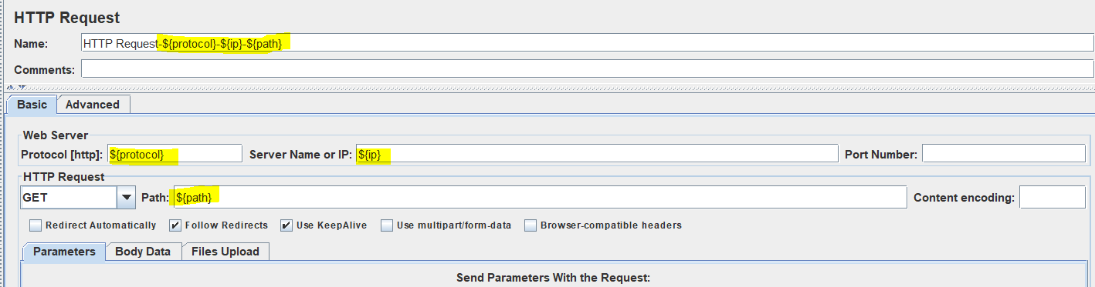

In csv file we provided 3 data rows + 1 column Header(if we don’t have column header in csv file then we can go to CSV Data Set Config n give values for column heading comma-separated like name,fname,surname for three columns of csv data file.Recycle on EOF means if we have defined only 3 rows of data n we set thread group no of user to more than 3 or loop count =3 then on 4th iteration time it will start considering the 1st row value n that means again it starts from row 1st value

Stop Thread on EOF means let say we have a file with 3 rows data so it will stop thread once all three rows are got considered.

Sharing mode allows the csv data set config to be access at specific levels like at all threads,current thread etc.

CSV Data set config values can only be used to config Samplers n not Thread Group nor Test Plan

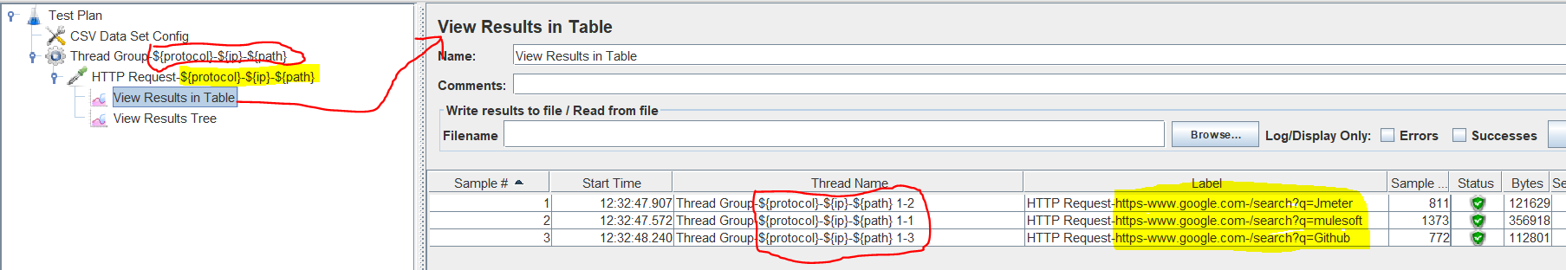



HTTP-Config Elements:

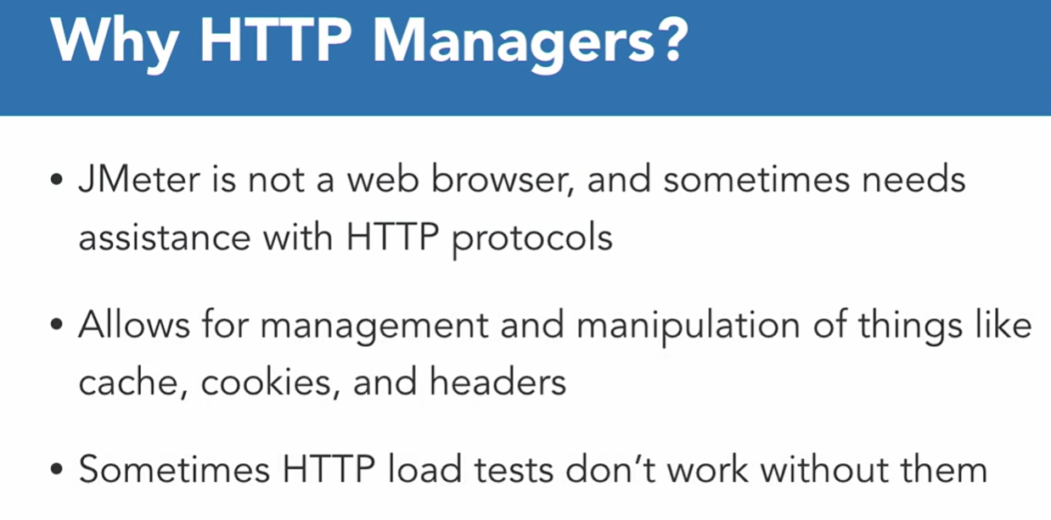

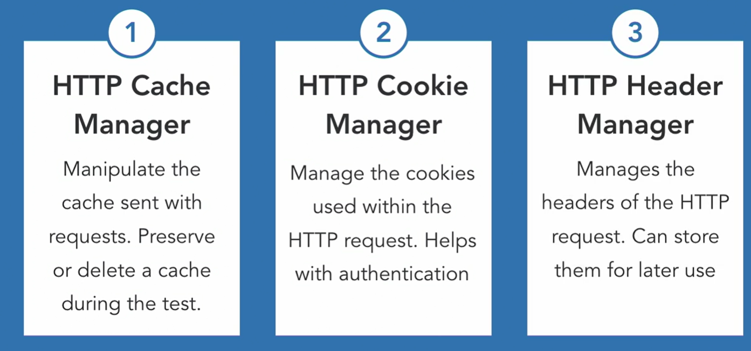

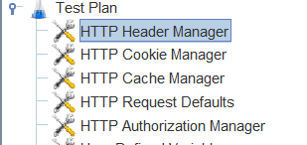

Header Manager =Used to manage headers

Cookie manager=used to manage cookies

Cache manager=used to manage cache

Request defaults=used to store all the default values

Authorization manager=used to manage auth

User defined variables=used to define variables n use them in test plan

Random variables: Lets u get the random number between min n maximum no u configured

* How to generate HTML Reports from the Test Plans Listeners output file?

To generate an HTML Report using a report file generated thru running a test plan we need to have three things:

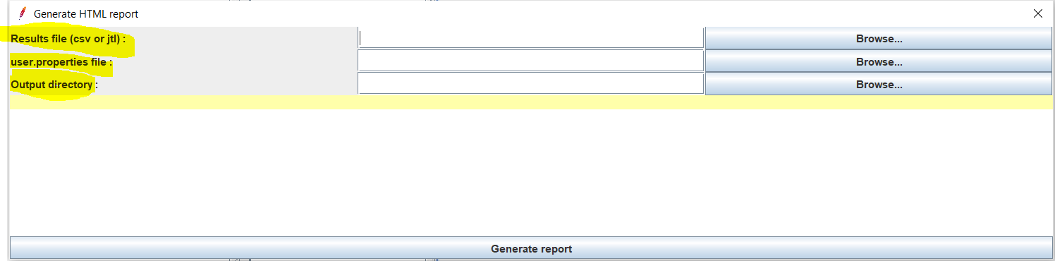

1. Result file: is a file that we configured in any listener n got the output of run into it
2. User.properties file:this is a jmeter file ,path of whose we need to configure .The path will be C:\apache-jmeter-5.5\bin.
3. Output Directory: this will be a directory path which should be an empty folder this is becoz the html reports will be generated here inside this directory/folder.

Let say we have below Test plan where we are storing the result using View results in Table and View Result Tree

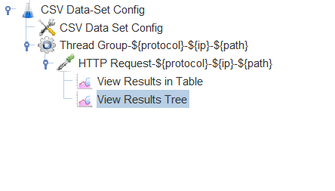

Path for result file of View results in Table is:

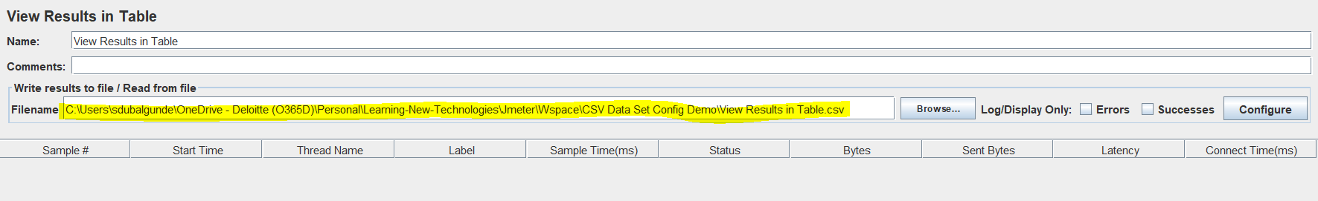

Path for result file of View Result Tree is:

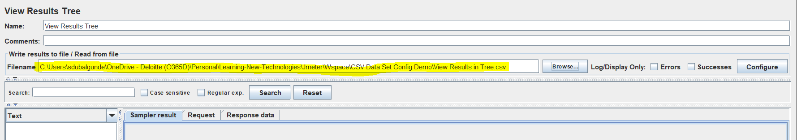

User.properties file

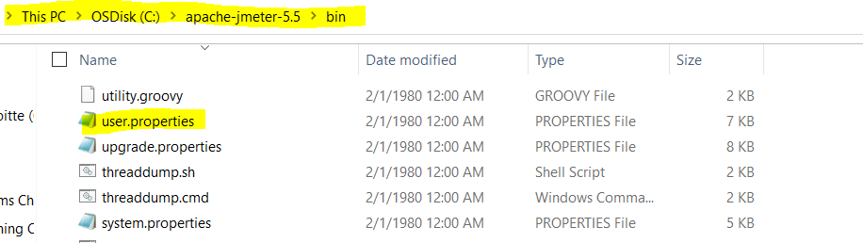

In this case we need to generate two reports for two diff listeners configured that is View Results Tree n View Results in Table so we need to have two diff. Empty folders/directories to store those reports so we can do below:

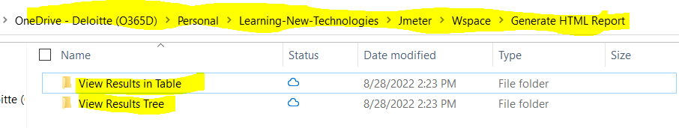

Both the folders are empty so we wont get any issue to generate the report. 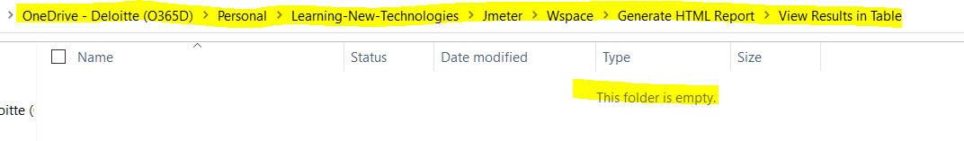

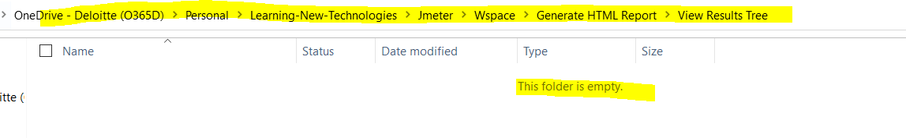

So before trying to generate a report lets run the Test plan so that we get some data to generate a report.

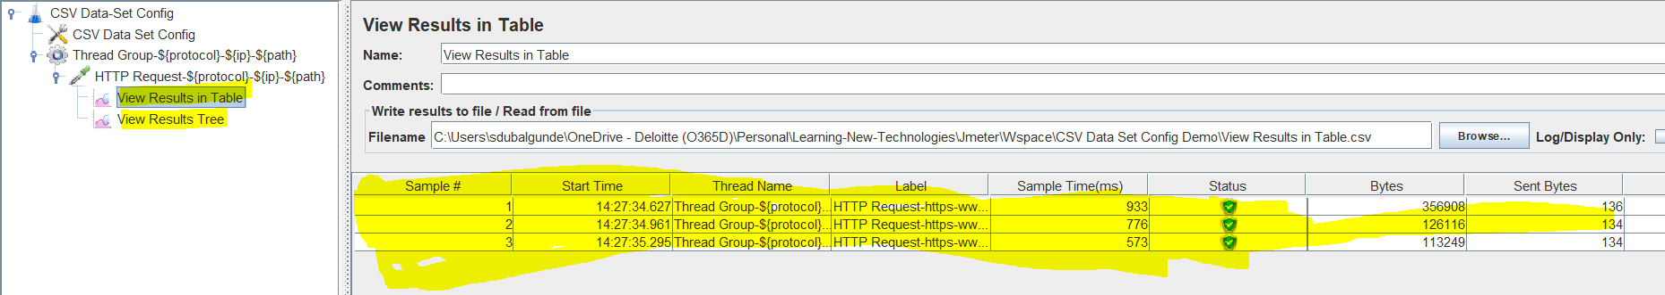

So after we ran the test plan,we need to generate report

To generate report we need to select tools->select Generate Html Report->configure the paths n click on generate report

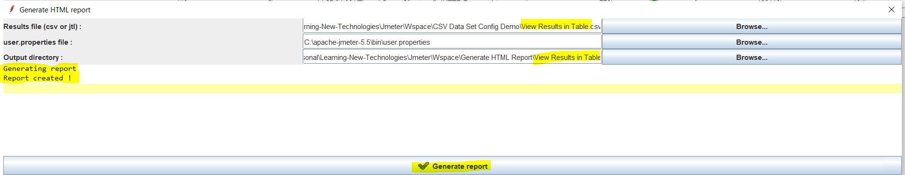

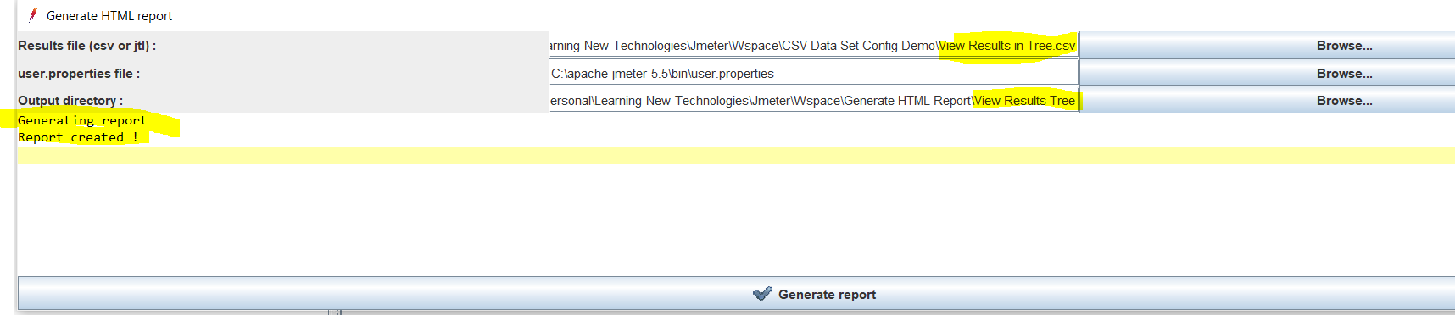

To check the reports go to the output folders location, 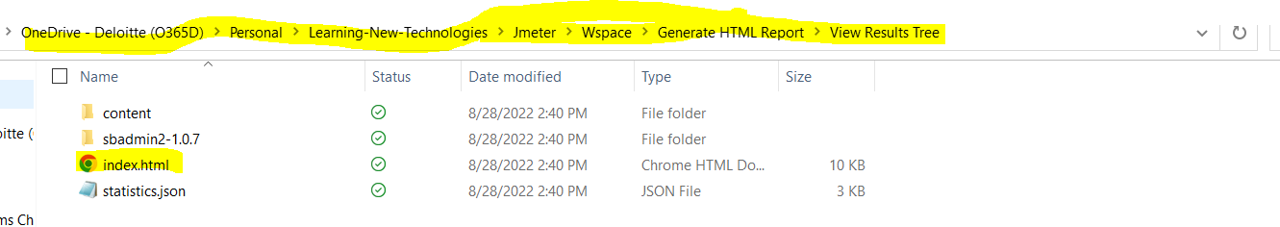

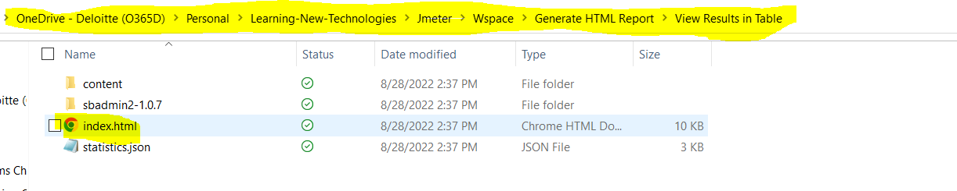

Click on index.html file to view the file on browser in HTML format.

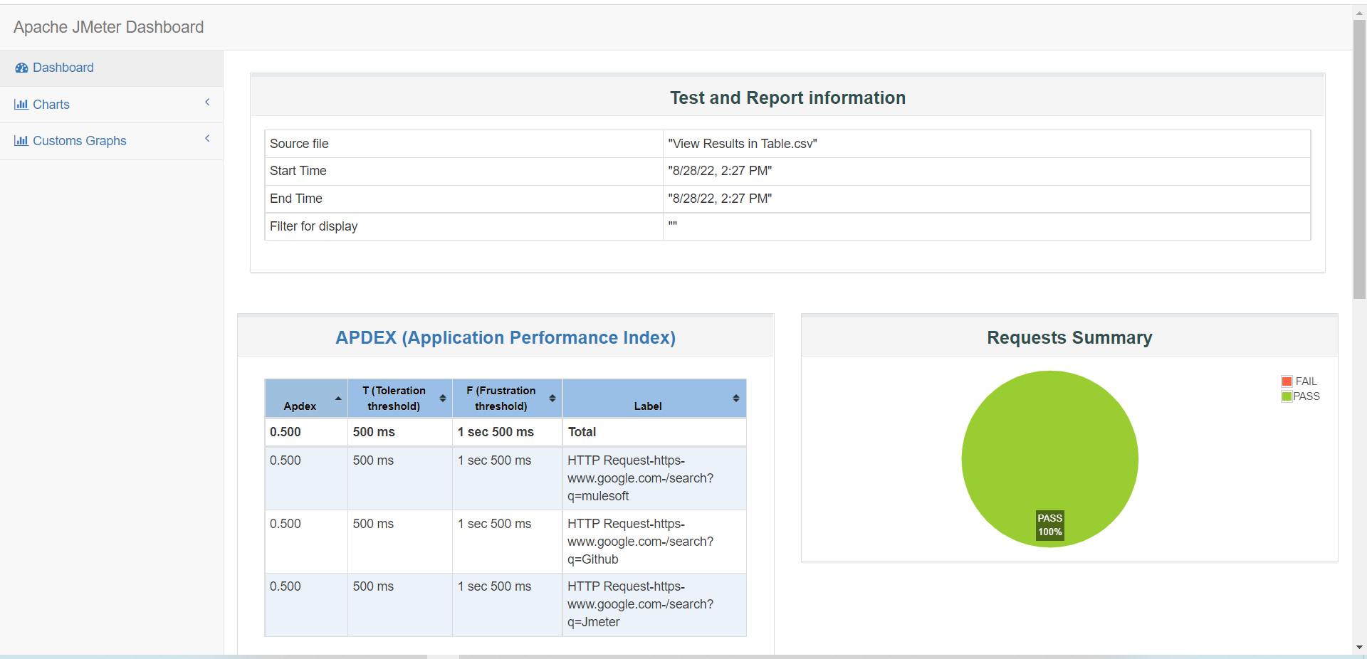

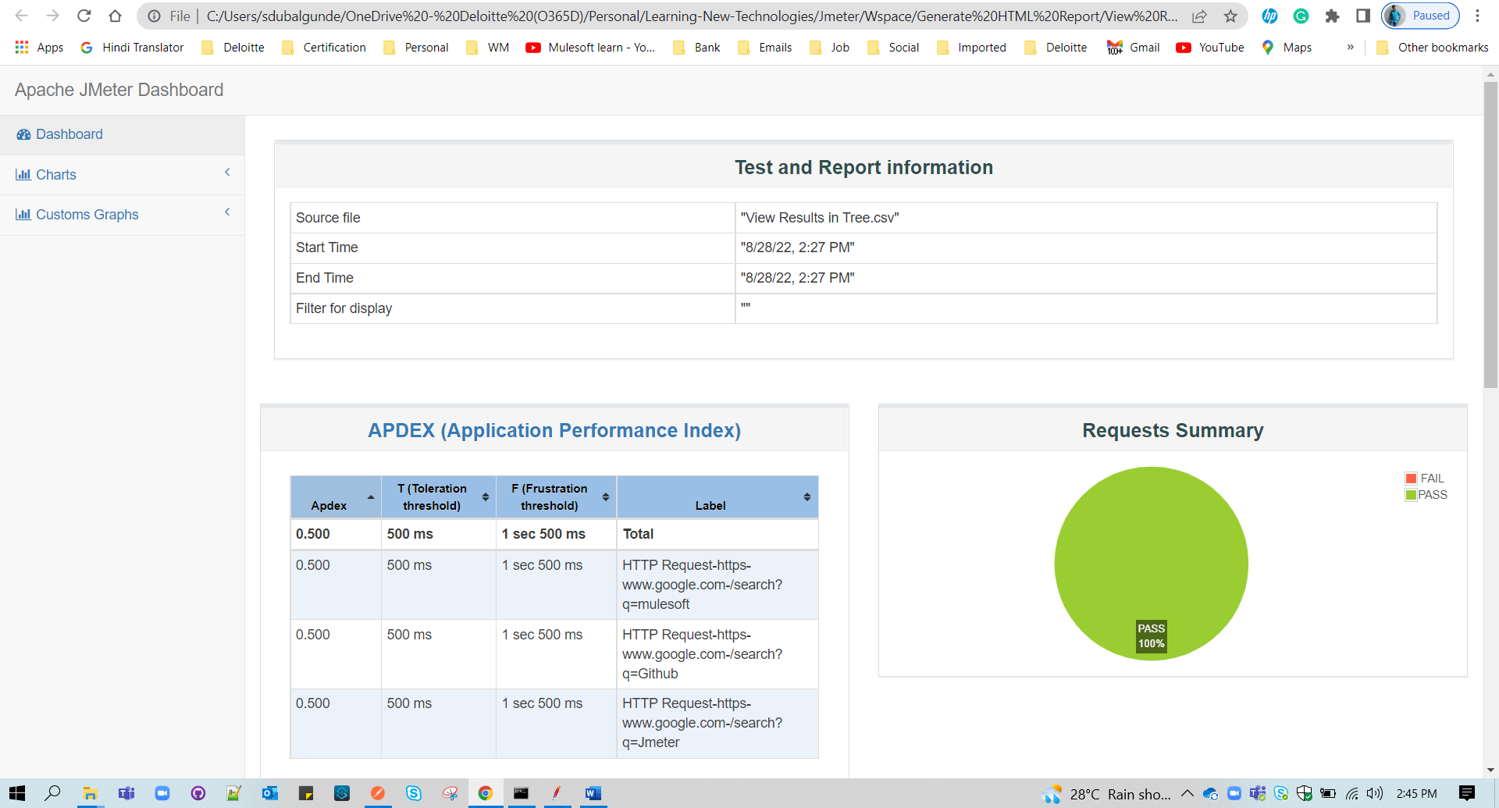

* How to extend Jmeter functionalities by adding new plugins n installing the Plugin Manager?

To add new functionalities in Jmeter like(Apart from standard plugins which provides various thread groups,samplers,Listeners)we need to add Plugins that are supported by Jmeter.

There are 2 ways to add plugins

1. Manually adding each wanted plugin by going to [Jmeter Plugin download Link](https://jmeter-plugins.org/wiki/Start/) n then selecting a wanted plugin and downloading the jar file from the site. N then pasting that jar file in Jenkins installation directory

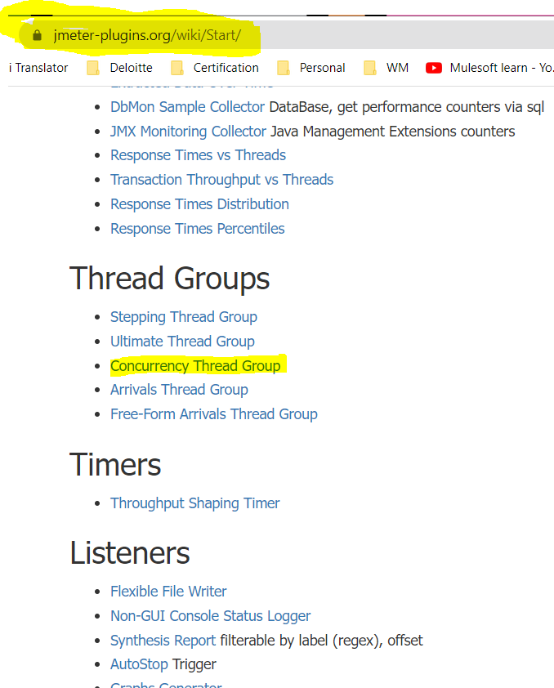 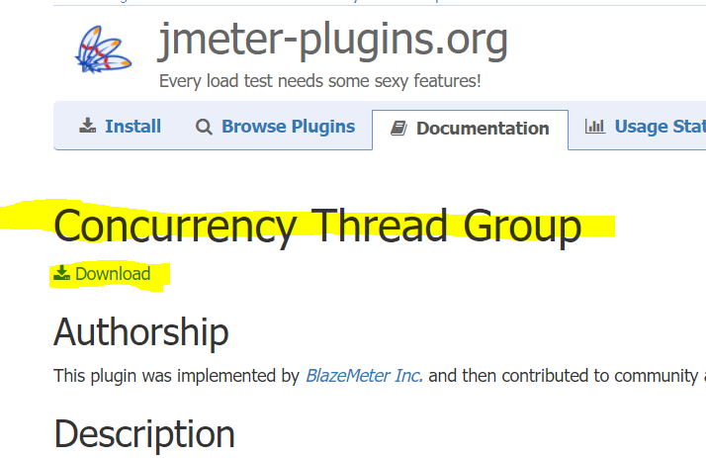

Once downloaded the plugin jar file,copy the jar file n go to Jmeter installation directory->lib->ext->paste the jar file copied .Restart the Jmeter to see the plugin added in Jmeter UI.

1. Way is to download the plugins manager jar file ->copy the downloaded jar file->go to jmeter installed path ->lib->ext ->paste the jar file ->restart the jmeter to see the Plugins manager added under Options menu bar .which will show the list of installed ,available,update in Jmeter GUI.

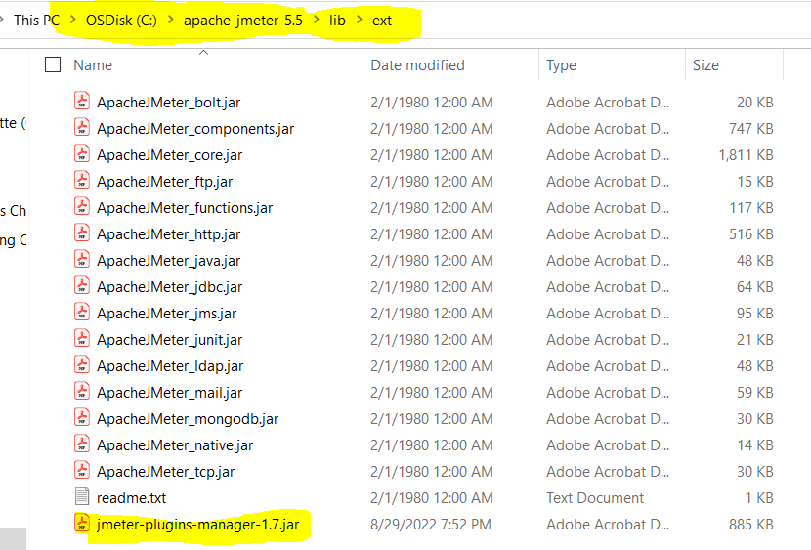

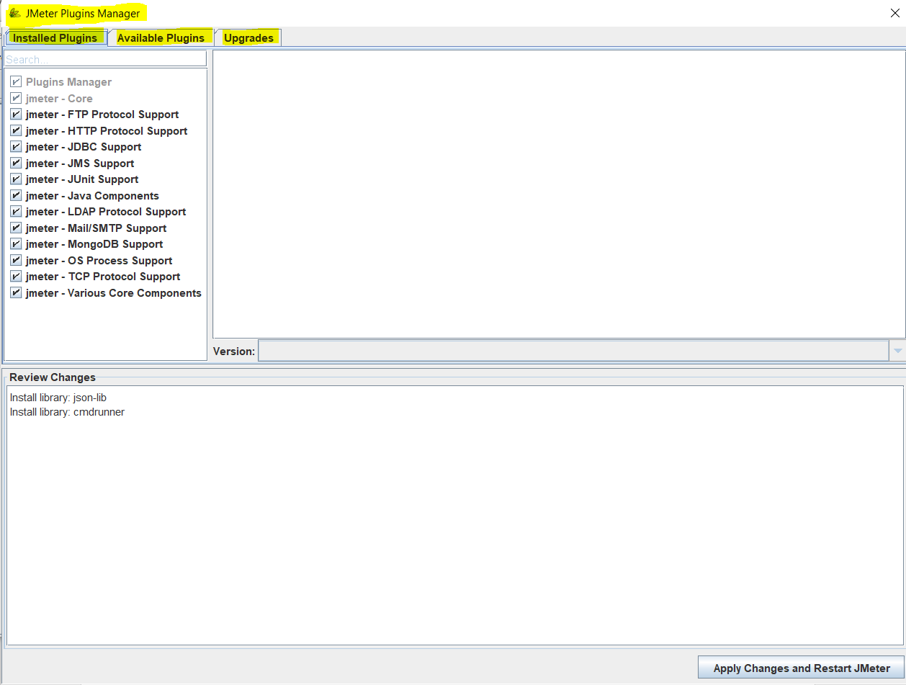

To install the plugins go to options->Plugins manager->available->select the plugin ->click on apply & restart

To uninstall the plugins go to options->Plugins manager->installed->unselect the plugin that u want to delete ->click on apply & restart

To check for new version/update for the plugins go to options->Plugins manager->Upgrades->if found some items then select the plugin that u want to upgrade ->click on apply & restart

* Functions and Variables

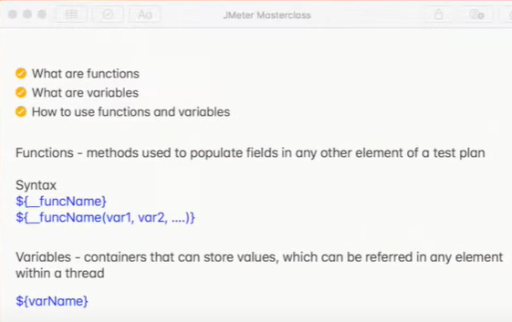

To write n use the function ,we can use Function Helper Dialogue button.



Click on the Function Helper button->select the function which you want to use n then give values n click on Generate n copy to clipboard once done you can use the function in any sampler (Http Request,Java Request etc.) 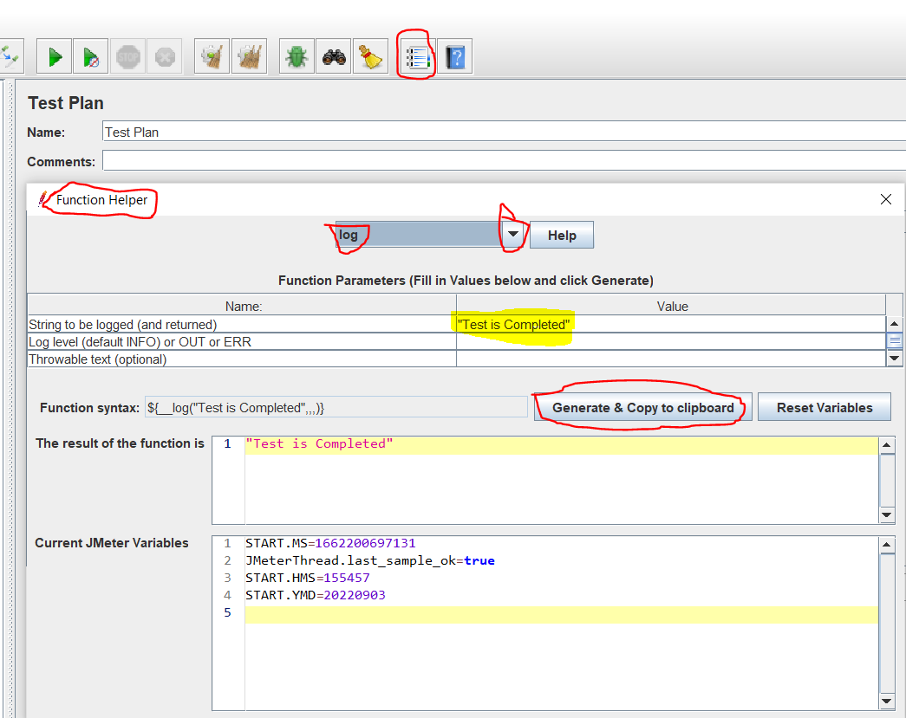

${__log(" Test Is Completed ! ",,,)} can be used in sample request. Like below:

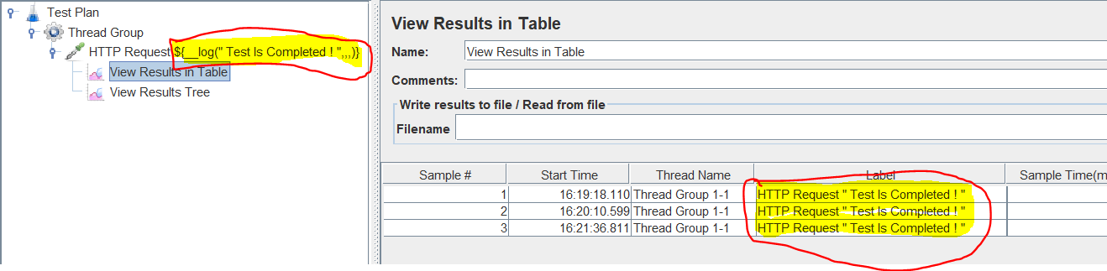

* Timers:

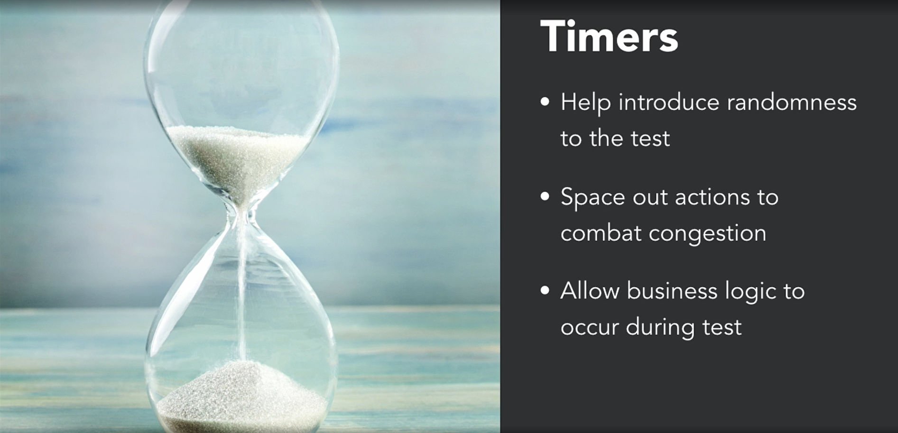

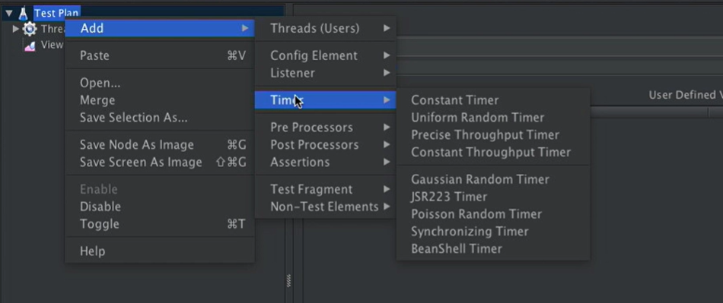

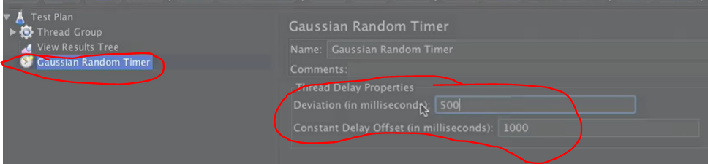will effect like below

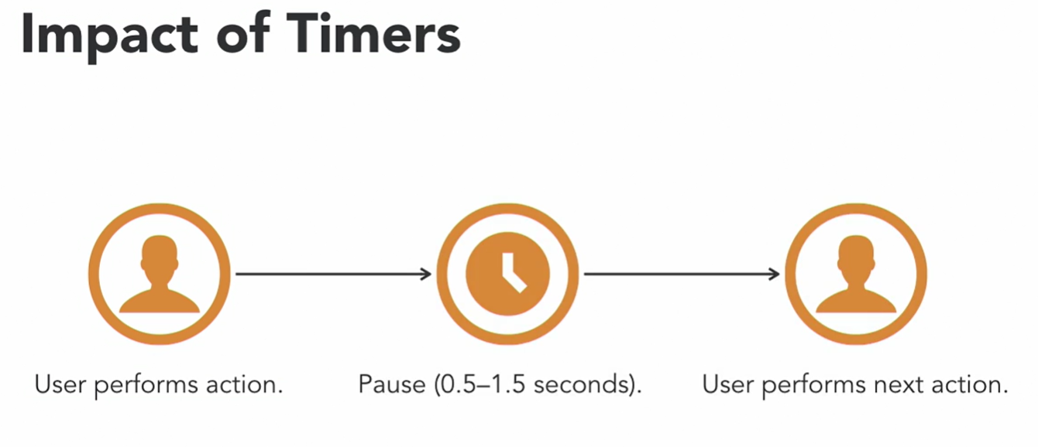

Concurrency Thread Group:

This is a component under Threads which is used to allow step-test in our testing where we will specify no of users who are testing based on the condition provided like

Target concurrency=500

Ramp-up time (min/sec)=60

Ramp-up step count= 1

In this case 500 users will be active for period of 60 min with 1 step-count i.e all 500 users will be active from 0 sec to till 60 min.

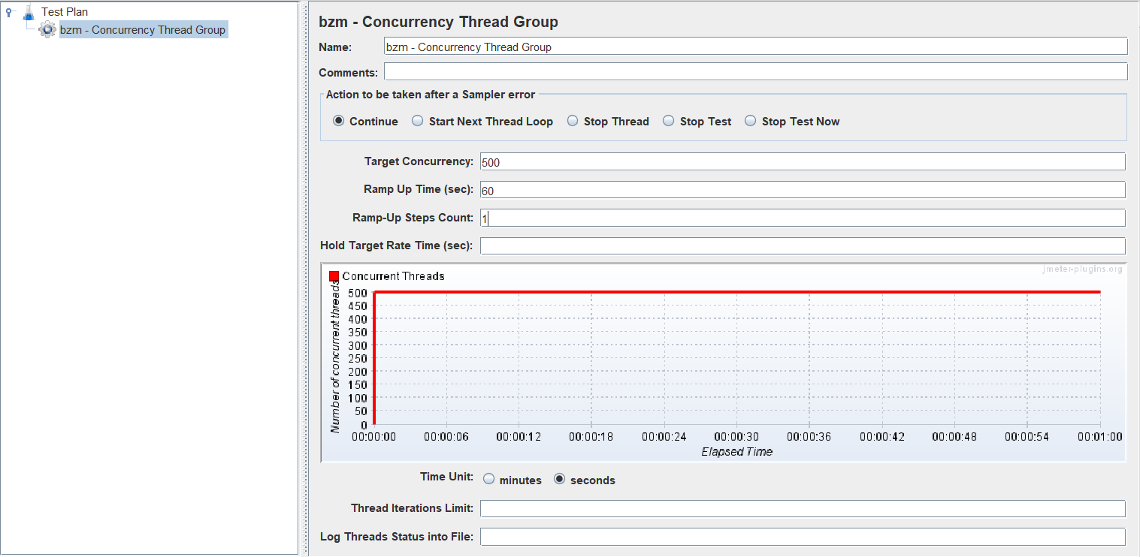

If Target concurrency=500

Ramp-up time (min/sec)=60

Ramp-up step count= 2

In this case 500 users will be active for period of 60 min with 2 step-count i.e first 250 users will be active from 0 sec to till 30 min. n then other 250 will be active in another 30 min.

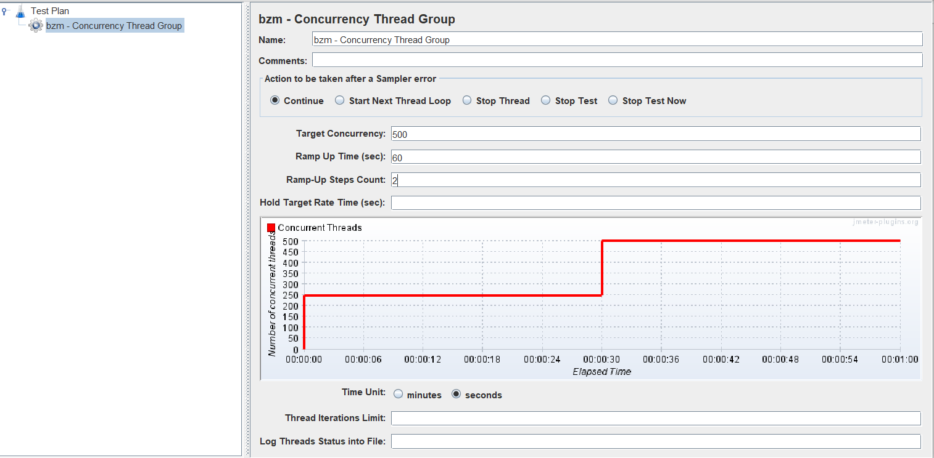

If Target concurrency=500

Ramp-up time (min/sec)=60

Ramp-up step count= 3

In this case 500 users will be active for period of 60 min with 3 step-count i.e first 166.66 users will be active from 0 sec to till 20 min. n then other 166.66 will be active in another 20 min. n then another 166.66 users will be active in another 20 min. 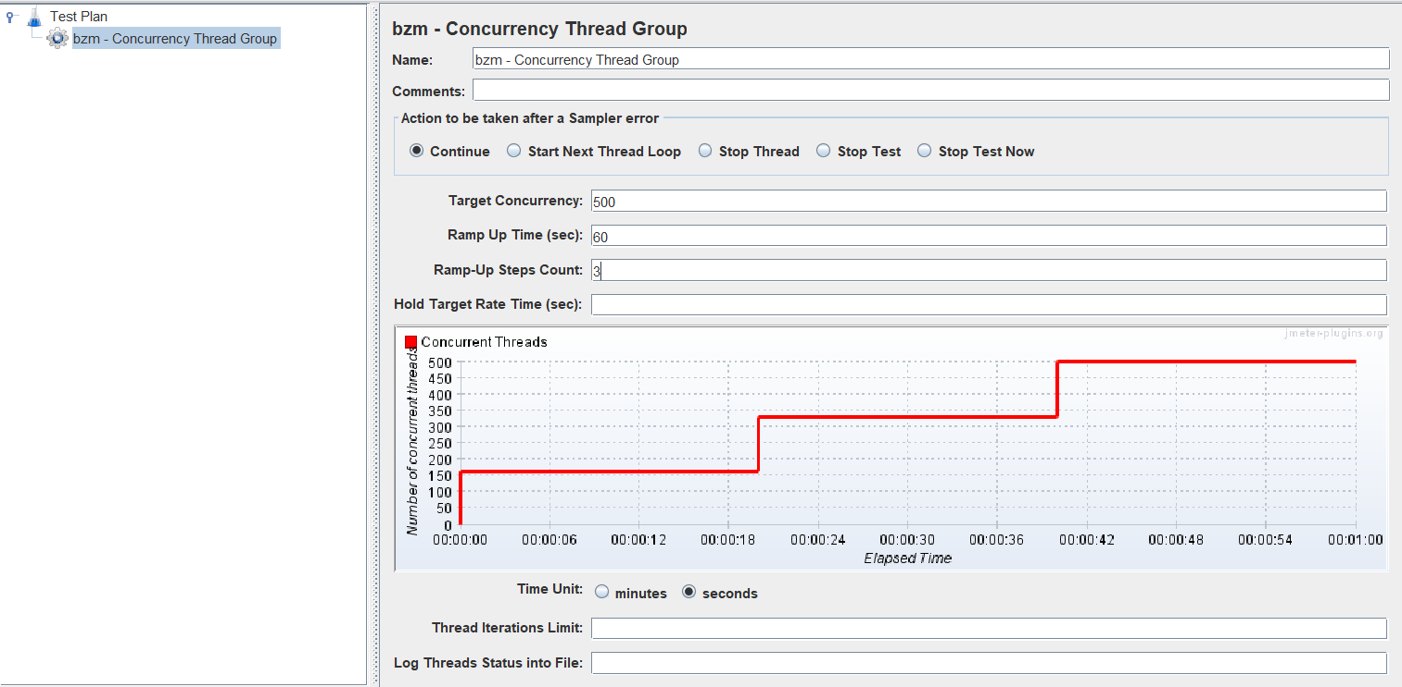

So the formula is below

Ramp up time/Steps count= time divided for each step, Target concurrency/steps count= no of users will be active

60/1=60 min time divided for each step , 500/1=500 users will be active

60/2=30 min time divided for each step, 500/2=250 users will be active

60/3=20 min time divided for each step, 500/3=166.66 users will be active